**Content**

# GIT HUB Commands

# Local SAP WEBIDE/BAS Installation

# FIORI Launchpad

# SAPUI5

# What is SAP UI5

# Before SAPUI5

# Advantages of SAPUI5

# MVC Architecture

# Difference between SAPUI5 and FIORI

# Structure of SAPUI5 Application

# Initial Flow of Execution

# Types of themes

# Complete Flow of Execution

# Back Navigation using router history

# Basic UI Elements of SAPUI5

# Dynamically change UI Element Properties

# Layouts

# Types of Layouts

# Grid Layout

# SimpleForm Layout

# Helper Layouts

# Validations

# ODATA Introduction

# ODATA Runtime artifacts

# CRUD Operations

# Connecting ODATA service to WEBID

# Types of Models

# List and MultiValue UI Elements

# LIST

# MultiValue UI Elements

# F4 Help Implementation using fragments and dialogs

# Why the dialog makes dependent of View

# Applying Filters at Back-end

# Applying Filters from Front end

# Sorting

# Formatter

# ODATA Read Operation

# Element Binding

# Type of Bindings

# Associations

# Create Operation end to end

# Update Operation End to end

# Delete Operation End to End

# Create Deep entity Front-end

# Create Deep Entity back-end

# File Upload

# File Download

# Export Table data to Excel

# Export Table Data to PDF

# Application Deployment to Server

# Batch Operation using EXCEL file Upload and save into back-end

# Charts

# Popover Scenario in Chart

# Internationalization

# UploadSet

# FIORI

# Introduction

# Master-Detail Application

# Work List

# List Report Application with CDS and Annotation Introduction

# CDS with Annotation

# List Report Application with Smart Controls

# List Report

# ALP-Analytical List Page

# OVP- Overview Page

# Extending Standard FIORI App Introduction

# Standard FIORI Application Configuration

# Extension of the Standard FIORI Application

# Extend the standard back end ODATA Service

# Front end application Extension

# Cross App Navigation

# Theme Designer

# Interview Questions

# SAPUI5 UI Elements value capture

# Apply Custom CSS

# Yeoman Generator

# ODATA Points

# Deploy SAPUI5 to server from BAS

**GIT HUB Commands :**

1. **git init** **-** To initialize the local repository
2. **git add .** **-** To add the all-project files to Local Repository.
3. **git add <File Name> -** To add a file(Newly added file) to existed local repository.
4. **git status** **-** To see what the files are been added into Local repository.
5. **git commit -m** **-** To commit the Local repository.(Give some comment in “ <Comms>”)
6. **git remote add origin <git repository URL>** **-** to set the Origin, to where we are going to push this project.
7. **git push -u origin master** **-** To push the local repository into remote GIT Repository.
8. **git remote -v -** To get the information of remote git repository, in where we are going to push the local repository.
9. **git push -f origin master -** In point 7 if we get the error like if we push the anything into master/Main Branch, we have to pull/Clone it first, then must push.

But here we are pushing it first time so must change the command to this.

1. **git remote set-url origin < git repository URL > -** If we already add the remote repository using step 6, if you changed your thought to change the repository name to some other then we must use this command.
2. **git config - -global user.email** - To get the mail id of the initialized git repository.
3. **git config - -global user.name** -To get the username of the initialized git repository.
4. **git config - -list -** To get the settings and repository details(Here we can find username and user Email Id.
5. **git clone - -branch <branchName> <remote repository url> -** To clone Specific Branch, instead of branch in above command we can use b. b is alias for branch.
6. **git branch <branch_name> -** To create new branch in local git repository.
7. **git checkout <new branch_name> -** Toswitch to new branch name in local repository.
8. **git pull origin <branch name> -** To bring new changes to existed project from GIT remote.
9. **git ls-files -** We can find the total files which are already committed into local repository.
10. **After Deploy the project from GitHub using clone into SAP BAS, if any error will come while executing this project like -** This is probably not a problem with npm. There is likely additional logging output above. Then we must execute the commands in command pallet of that respective project.

**npm cache clean - -force**

**npm install.**

1. **If you have made some changes in project (Which project already existed in the GITHUB) then you must push those changes to GITHUB as below commands.**

To find the changes made in which files **– git status**

We must add those files into existed local repository – **git add <File1> <file2> …….**

Then must commit the local repository **–** **git commit -m “<Your-Comments>”**

Then push the changes to Remote GITHUB repository **–** **git push -u origin master**

1. **If we want to pull only files in which changes was happen from GITHUB to SAP BAS by below command.**

**git pull origin master**

1. **Process to Push the Project to remote GITHUB Repository from SAP WEBIDE Personnel Edition.**

* Initialize the Local Repository **– First right clicks on Project->Git->Initialize Local Repository.**
* Connect Local Git repository in SAP WEBIDE with Remote Repository of GITHUB **–** **right click on Project->Set Remote->Name=origin & URL= “<Remote Repository URL>”->Press OK ->again Press OK.**
* We must commit all Project files to Local Repository **– from Right side Select Git Pane-> Select Stage All->Give Comment->Press on Commit Button.**
* To Synchronize the GITHUB repository with Local Repository **– Click on PULL from Git pane.** Once pull action completed, we will notice README.md file in Local Repository (which is created in GITHUB Repository).
* Push our Local changes to Remote GITHUB **–** **Press Push in GIT pane->Remote Branch->Select Branch and press ok.**

1. **To store the Remote GITHUB username and password in SAP BAS:**

We just need to create a **.netrc** file in $HOME directory and add below syntax.

In business application studio to open **home directory** need to follow below path.

File🡪 Open workspace 🡪Select USER and click on Open.

Right click & select create new file (or press Alt N from keyboard) in root directory USER. Enter file name as .netrc and add the below code.

machine github.com

login <Login ID>-s4fiori111

password <Password>

1. **Push SAP Web IDE Project into Remote GitHub:**

**Steps:**

* 1. Right-click on your project folder and click **Git 🡪 Initialize Local Repository**.
  2. We need to connect Local Git Repository of SAP WEB IDE with our GIT HUB Repository.
     1. Right-click on our project folder and click Git🡪 Set Remote.
     2. In the configure Git Repository dialog box, enter our GIT HUB Repository URL.
     3. Click on OK - This automatically executes a fetch from the remote repository, and you can view the branches/commits that will be fetched. Click **OK**.
  3. Verify GIT Repository.

Your project is now initialized with a Git repository and linked to the GitHub platform. You can open the Git pane on the right sidebar to verify this.

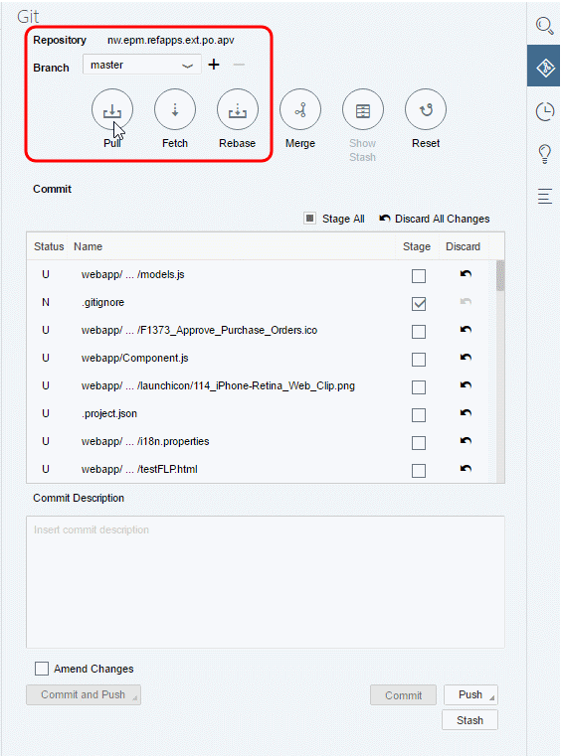

* 1. Stage and commit files:- Commit the project files to the local Git repository by doing the following
     1. Make sure the files are staged (the Stage checkbox is checked).
     2. Enter a commit message.
     3. Click Commit.

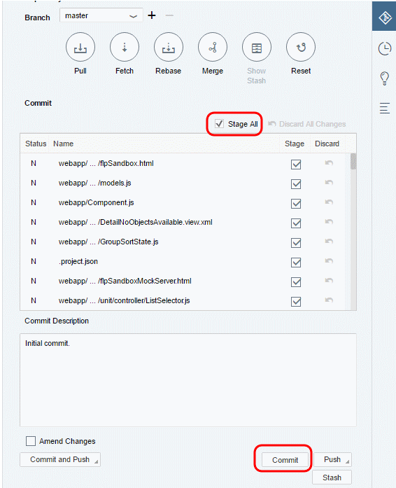

* 1. Pull from Remote GIT HUB: - To synchronize the GitHub repository and local repository changes, click **Pull**. Enter your GitHub credentials.

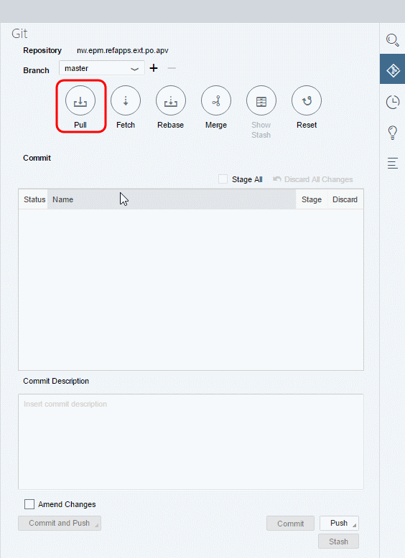

* 1. View Downloaded README: - Once the pull is complete, you’ll notice the README.md file that was created on GitHub is now available in the SAP Web IDE project workspace.

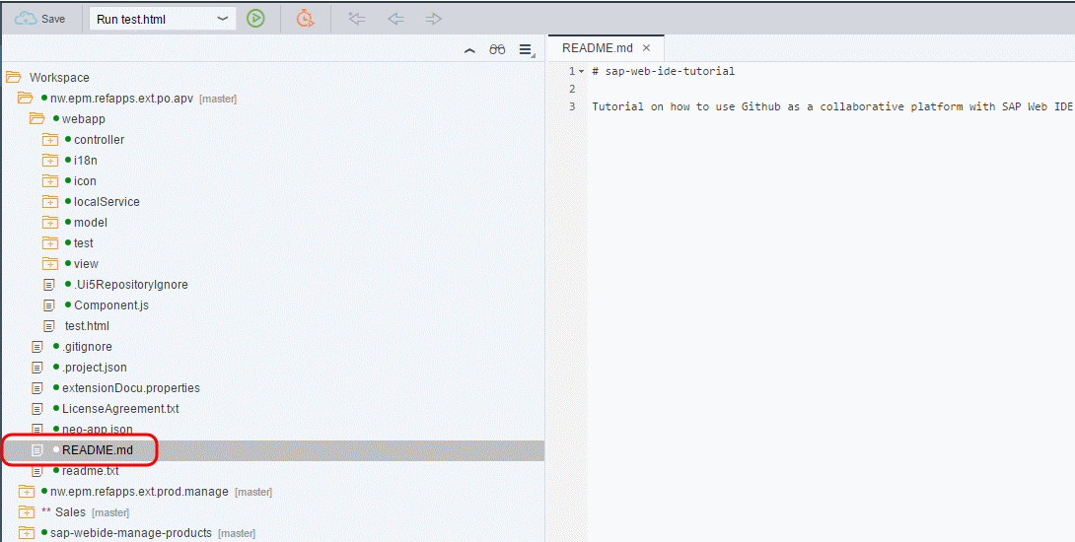

### Push your local changes to GitHub: - Click **Push** and select **Remote Branch.**

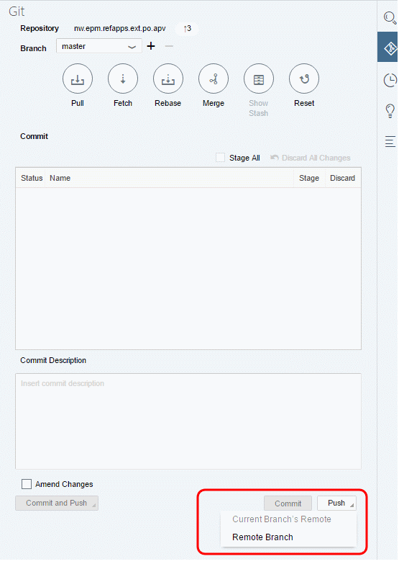

Select **origin/master** as the remote branch and click **OK**.

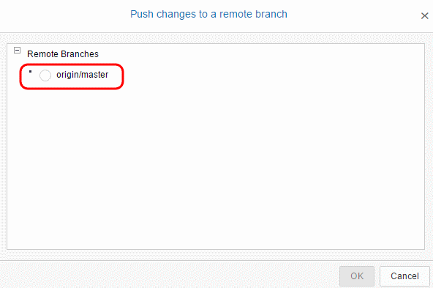

Enter your GitHub credentials and click **OK**.

Once the push is complete, you will see a notification message on the top-right corner in GIT Pane.

* 1. Check Published changes: - Go to your organization on GitHub and you will notice that the changes are now published.

**Reference Link: -** <https://developers.sap.com/tutorials/webide-github-import-project.html>

**Local SAP WEBIDE/BAS Installation-2**

1. Installation is two parts which are

**Front end Installation:**

Front end design tools are either SAP WEBIDE or SAP BAS (Business application studio)

**Steps to Local SAP WEBIDE:**

1. Install java 1.8 only: when it is installed two fodders will created in our C drive which are jdk (java Development kit) and jre(Java Run time Environment). The path is C->program files->Java->jdk and jre.
2. Set the Java path in Environment variables like

First, we need to copy the path from jdk file as C->program Files->Java->jdk1.8.0_231->bin. Then need to paste this path in Environment variables as below.

Right click on This PC->properties->advanced system settings->Advanced->Environmental variables-> under system variables ->path->click on Edit->again click on Edit->paste above path and click on OK,OK,OK.

1. We can install SAP WEBIDE it is a cloud-based tool. In real-time our client will take the licence for SAP WEBIDE there is no tool to install it is a URL when we click on URL it will automatically open in Cloud itself means in browser. This SAP WEBIDE licence is 45000/month.

SAP has provided installable SAP WEBIDE in local machine for practice purpose which is called **local WEBIDE**.

Need to download the SAP WEBIDE ZIP folder. We need 7 ZIP software to extract it.

1. Once it extracted double click on this folder, we can find the eclipse folder (SAP developed WEBIDE based on eclipse much better than eclipse), double click on this eclipse folder we will find the Orion double click on it and minimize the command prompt file.
2. After all, above steps we need to open below URL in browser.

<http://localhost:8080/webide/index.html>

This SAPWEBIDE running from local machine host 8080.

**Note:** Don’t forget the password, if forget delete the extracted WEBIDE folder and re extract and do as above.

**Steps to Business Application studio:**

NO Installation required.

We must open an account in **SAP Business Technology Platform.**

<http://account.hana.ondemand.com/#/home/welcome> click on sign in with SCN account.

<https://hanatrail.ondemad.com>

**Backend Installation:**

1. SAP GUI 750 while installing this Microsoft .net framework installation may require.
2. Add our server in SAP Logon.
3. SAP UI5 Applications we can develop using SAPWEBIDE and SAP BAS tools, then what are the differences between them.

|  |  |
| --- | --- |
| **SAP WEBIDE** | **SAPBAS** |
| If client is having different backend systems in his own client environment, then WEBIDE is best choice. | If client has most of the systems present in cloud, to develop an application need to pull the data from cloud database then BAS is best choice. Cannot develop the application using WEBIDE. |
| Introduced in year 2014 | Introduced in year 2019 |

1. Configure the Back-end system into SAP Business application studio.

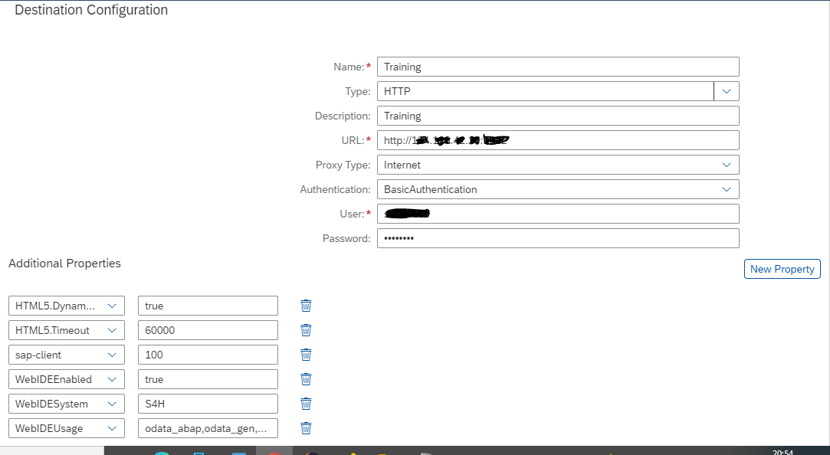

**FIORI Launchpad**

1. **Customize the FIORI Logon Page:**

First, we need to upload/Import the MIME Objects MIME Repository under below Path and as per below steps.

**Steps:**

1. Goto **SE80** 🡪 Open MIME Repository 🡪 SAP 🡪 Public 🡪 BC 🡪 UI2 🡪 logon 🡪 img, here we need to download the existed images and upload our own images into same folder.
2. Goto SE24 and copy the standard class /**UI2/CL_SRA_LOGIN** and create one custom class.
3. Goto **INIT_DEFAULT_PROPERTIES** methodin created custom class and double click on method to change the existing logic.
4. Here multiple lines of code related to background image, logo... etc. Here we need to change the path to which we are interest to change.

After changes has been done, need to activate the entire class.

1. Goto **SICF** Tcode and open the path default host 🡪 sap 🡪 bc 🡪 ui5_ui5 🡪 ui2 🡪 ushell, double click on this ushell press on edit button and goto **error pages tab** click on **configuration button,** select the **define service-specific settings** radio button, select custom implementation button on right side and replace the existed standard class with our created custom class.
2. **Customize the SAP FIORI Launchpad using the Theme Designer:**

Theme designer is a browser-based tool with a **WYSIWYG designer,** therefore any change that you make can be viewed immediately in the browser. This tool allows you to develop your themes by modifying one of the theme templates provided by SAP with our corporate identity, colors and company logo.

The below figure shows the SAP FIORI Launchpad architecture with the UI Theme Designer.

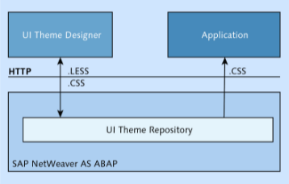

The top layer shows the UI theme designer built on SAPUI5.The UI theme Repository on the ABAP frontend server contains standard themes and custom themes. The theme designer generates LESS files, CSS Files and images which are saved into the repository. These files are received from HTTP calls. The application is loaded with CSS files from a chosen theme.

The **transaction codes** will be used while working with SAP UI theme designer.

* **UI5/THEME_DESIGNER** **–** This is used to create, edit, copy, delete and rebuild/upgrade the theme.
* **UI5/THEME_TOOL –** This is used to delete, export, import, and transport and to analyze theme content.

**Create custom theme:**

How to create a new theme for SAP FIORI Launchpad and how to apply it to the default template.

**Steps:**

* Log in to your ABAP frontend server.
* Run Transaction **UI5/THEME_DESIGNER** to open the UI Theme Designer.
* Select a standard theme click on open (Note: you can create a custom theme by modifying the SAP provided theme).
* Enter the **Link to Application,** here we want to change the theme of SAP FIORI Launchpad, so enter the FIORI Launchpad URL. Provide the application name is optional.

The UI **Theme designer provides various options** based on designer skill.

* **Quick Theming:**

Using quick theming we can change the background colors, fonts and images. The following steps how to do this for our custom theme.

1. First, we will add a custom background image and logo, upload the images by click the button next to the menu.
2. After uploading the background image and icon, the quick theming tool will replace the SAP standard images. Similarly, we can change the colors, font and etc.

* **Expert theming**( not for productive use, subject to change)**:**

To use this tool, select Expert option and enter **“tileiconcolor”** in the search box to filter the objects.

You can change the colors for the **sapUshellTileColor** field, and that will change the colors of the icons in the tile. Your output should reflect all the changes you’ve made until now, and you can toggle between the Original and Preview mode.

* **Color pallete** ( not for productive case: subject to change)**:**
* Manual LESS or CSS editing.

**Save and Build:**

The next step is to save and publish the changes to the ABAP frontend server. Follow these **steps:**

1. Click on Theme > Save & Build.
2. Enter the Theme ID and the Title, and then click OK.
3. After the custom theme is saved and built, you should see a confirmation message. Click OK.

**Test the Custom Theme:** we’ve successfully created a custom theme and then uploaded to the ABAP frontend server. Next, we’ll have to test the custom theme by following these **steps:**

1. Log in to the ABAP frontend server and run Transaction **UI5/THEME_TOOL.**
2. Scroll down or search for your custom theme.
3. Double-click on Info.
4. Copy the URL and paste it at the end of the SAP Fiori Launchpad URL with an “&” before the URL. Now, let’s test the theme by running the URL. You should now see the new custom theme applied to your SAP Fiori Launchpad: https://<host>.<domain>:<port>/sap/bc/ui5_ui5/ui2/ushell/shells/abap/Fiorilaunchpad.  
   html?sap-theme=CorporateTheme@http://<host>.<domain>:50000/  
   sap/public/bc/themes/~client-120/~cache-2VCj7NrjFnVx-uDZ8vm6HqrJVPsI
5. The next step is to overwrite the standard theme with the custom theme, which you created in the previous steps. Run Transaction **/UI2/NWBC_CFG_SAP.**
6. Set the SAP_FLP parameter value to the custom theme which you created previously.
7. You should now see SAP Fiori Launchpad with the new theme.
8. **Adding background images to Fiori tiles:**

**Steps** to add an image to FIORI tile as a background image.

1. Go to transaction **/UI5/THEME_DESIGNER**in our gateway server. This will open up the UI5 theme designer in our browser.
2. Now select any one standard theme and choose **“Open”.** This would create a base theme of the chosen std. theme upon which you can make your changes.
3. In the next screen you can give your Launchpad link and a name in this page and click add.
4. Now you will have different option to customize this theme by choosing different options in the right-side panel. For our requirement, we are going to assign different backgrounds to Track Shipment and Track Sales order App.
5. Now to know the specific internal ID which differentiates each Fiori app, right click on your application and choose inspect element. (In FIORI Launchpad).
6. Here the highlighted CSS attribute **<data-targeturl=”#SalesOrder-track”>** can be considered as unique per application. Here **“data-targeturl”**is the parameter and **“#SalesOrder-track”**is its value.

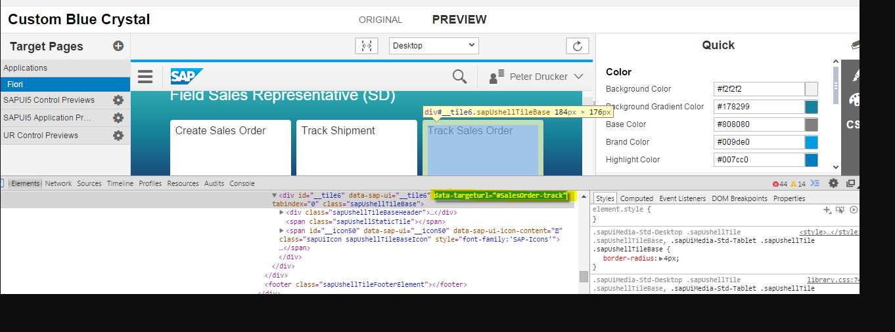

1. After fetching the unique parameter, use it in your CSS to assign the image for that tile using below sample css code

*[data-targeturl = “#SalesOrder-track”]{*

*background-image: url (“<image page>”);*

*background-repeat: no-repeat;*

               background-position: center;

*background-size: 200px 200px;*

Once entered the above CSS, you can see the image got updated.

1. Save and Build.
2. Adding the theme to Launchpad can be achieved using transaction **/n/UI2/NWBC_CFG_CUST.**

Here create and enter as below and save.

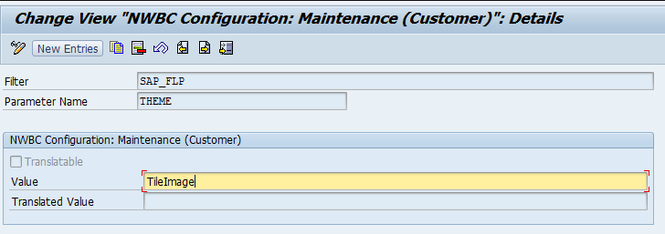

1. Now the Launchpad runs on the updated theme.
2. **URL for Launchpad:**

**Launchpad for Designer- Admin**

[**http://124.123.42.25:9222/sap/bc/ui5_ui5/sap/arsrvc_upb_admn/main.html?scope=CONF&sap-client=100&sap-language=EN**](http://124.123.42.25:9222/sap/bc/ui5_ui5/sap/arsrvc_upb_admn/main.html?scope=CONF&sap-client=100&sap-language=EN)

**OR**

**Tcode** - /UI2/FLPD_CONF

**Launchpad for Users – to Access the Applications.**

<http://124.123.42.25:9222/sap/bc/ui5_ui5/ui2/ushell/shells/abap/FioriLaunchpad.html#Shell-home>

**To test the UI5 application from SICF Tcode.**

<http://124.123.42.25:9222/sap/bc/ui5_ui5/sap/zz1_r9_mstrdtl/index.html?sap-client=100#/productsSet/PRD001>

**SAPUI5**

1. **What is SAPUI5?-1**

SAP UI5 is latest technology to develop responsive web-based business applications in SAP based on MVC architecture, the speciality of SAPUI5 is responsive behaviour means applications can run in desktop, mobiles, and tablets without any separate development for any device.

SAP UI5 introduced in the Year 2013.

1. **Before SAPUI5 there are three technologies** used to web-based business applications are

* BSP
* WebDynpro JAVA
* webDynpro ABAP

**The disadvantages of above-mentioned technologies** compared with SAPUI5

* Very slow in response. Because they are server-side applications, for each action they hit the server.
* Supports only for Desktop.
* Very poor look and feel, only white, blue colors are possible.

1. **Advantages of SAPUI5?**

* Vary fast in performance. Because it is a client-side technology means except crud operations all other operations like navigations, user actions will execute in browser itself.
* Supports all devices (desktop, mobiles, and tablets)
* Very rich look and feel.
* Any colors are possible, you can make your application colorfull.

1. **MVC Architecture:**

MVC stands for Model, View and Controller, this architecture specifies SAPUI5 application into three significant layers as

* **View :** Code for Screen Design
* **Controller :** Code for handling user actions, calling crud operations and validations.

Each view will have its own controller with same names. By this application maintenance is easy. All the Controllers are java script files.

* **Model** : Deals with data and data manipulations.

Front end SAPUI5 application is the combination of XML and Java Script based framework which does not understand ABAP based back-end system either ECC/HANA. The mediator SAP Gateway system, this gateway system will do the entire backend business logic (CRUD operation logic) will be exposed as ODATA Service.

ODATA is a universal open data protocol which is accessed by any frontend technology. Through which communication is possible between frontend and backend.

1. **Difference between SAPUI5 and FIORI?**

SAPUI5 is the framework technology given by SAP, using this SAPUI5 technology there are two words famous which are.

SAPUI5 application and SAP FIORI

**SAPUI5** is the purely custom development by technical person by UI5 framework.

**SAP FIORI** is based on the common business scenarios SAP developed some applications those are called FIORI Applications, even FIORI applications also developed using SAPUI5 framework.

Note: SAP FIORI is not a technology.

**SAP FIORI has again sub parts which are**

* **Standard FIORI apps**, we can extend these apps based on customer requirement.
* **FIORI template-based applications:** instead of creating an application from scratch SAP has given some templates, if we use those to create the applications 90-95% of code will generate automatically remaining we need to write.
* **FIORI Element based Applications**: which are based on smart control and CDS with Annotations.
* **FIORI Launchpad**: is a single point of end user login to access the FIORI applications.

Why this FIORI Launchpad is for access the different multiple applications by single login.

1. **Structure of SAPUI5 Application: -3**

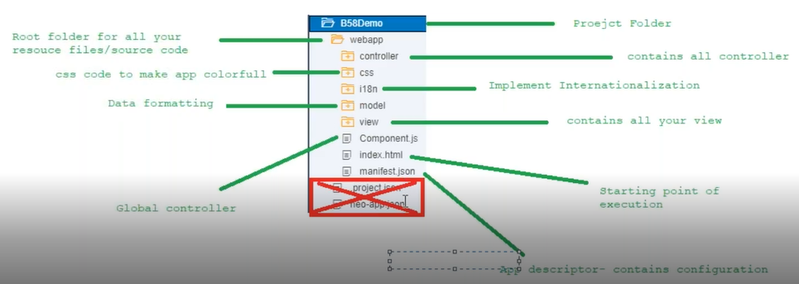

1. When we create a project in WEBIDE/BAS we will get below default structure of project.
2. After completion of project creation, we have to deploy this project to Gateway system, in deployment process folders under webapp folder will deploy, reaming two files **neo-app.json** and **project.json** not deployed because they are nothing to do with deployment, they are special type of files for WEBIDE. Developers should not touch the project.json file, which stores the project related information.

neo-app.json is automatically through wizard configured something to connect Gateway system.

1. **SAP recommends as empty as possible in style.css file** because we cannot apply any custom CSS to standard FIORI applications. So, if we have applied custom CSS to custom app when we come to FIORI Launchpad user experience custom app is full of colors, but standard app is not much. Here the uniformity is missing so SAP Recommends don’t apply colors in CSS you can use css for other purpose not for colors.

If we want to make them colorfull sap has provided theme designer at FIORI Launchpad by this each app and tiles, feel same user experience.

Settings->appearance.

1. I18n stands for internationalisation, which means supporting our application in multiple languages. Based on the selected language while login.

For each language contains one i18n file under I18n folder with name prefix as **i18n_<language code>.properties**, the default i18n.properties file is for English.

1. Component.js is the global controller, any view and any controller can use this component.js.
2. **Initial Flow of Execution: -4**
3. Which means, from starting file index.html to execution of output, in between what are the files will be getting loaded and what is the sequence of file loading and what those files contains.
4. The **execution of flow** is as below.

Index.html(here first SAPUI5 runtime (sapUI5 bootstrap) will execute 🡪 component.js 🡪 manifest.json(in manifest.json it will execute the root view) 🡪 view1.view.xml 🡪 view1.controller.js 🡪 output.

Inside Index.html we don’t write any code.

1. **Types of themes** 🡪 sap_bluecrystal

sap_hcb

sap_belize

sap_belize_plus

sap_fiori_3

sap_fiori_3_dark

1. In any java script file, we can find **“use strict”** which means that java script file run in strict mode so that all possible errors we can see in console area.
2. In every Java script file we will following the scoffolding template as below, here **.extend** means the Controller features extend to View1 controller.

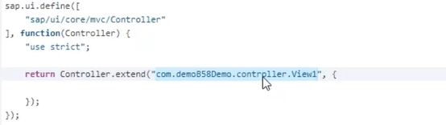

1. In **component.js** file we load the meta data, initially we use to maintain the all-configuration related to metadata in component.js, in the year 2015 SAP has modularize this configuration code into configuration file called **manifest.json**.

manifest.json is called configuration file having three sections.

* **Sap.pp**  **–** Application related configuration.

**Id:** Everyapplication contains a unique application ID; this ID is helpful during the deployment and configuring your application as a title in launchpad.

* **Sap.ui** **–** UI Related configuration.
* **Sap.ui5** **–** UI5 related application configuration.
* **rootView**: In root View configuration very first, which view will load in browser.

1. **Complete Flow of Execution:-5/6**
   * + 1. Initial flow of execution is all about the related to one View, but in real time we have multiple views and with navigation.
       2. SAP has recommended to implement complete flow of execution as per the views as we want.

To navigation between multiple views, we need complete flow of execution whereas initial flow of execution applicable for single view (If requirement fulfil with single view).

* + - 1. The **Execution flow** is as below

Index.html(here first SAPUI5 runtime (sapUI5 bootstrap) will execute 🡪 component.js 🡪 manifest.json(in manifest.json it will execute the root view Configuration ) 🡪Application base(App.view.xml) 🡪 **view container(sap.m.App)** 🡪 actual Views(view1,view2……) will be load into the view container on demand by router.

* + - 1. **View container:** view container holds the multiple views, but it will execute only one view at

a time. These views will be loaded into view container by the router which is s/w or library. **The job of the router** is pick up the view from view folder and load it into view container.

* + - 1. **The purpose of the view container** to storing the views in view container is navigation between view is very easy.
      2. **Application base(App.view.xml):** SAPrecommends keeping view container in another view which is called application base view( App View).
      3. **Prerequisites when we follow complete flow of Execution:**
* Skelton of the view should have Page content only.

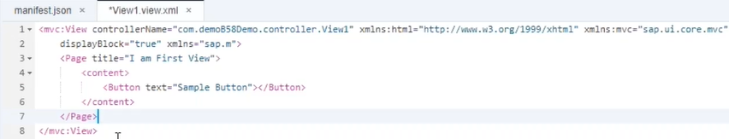

* App.view.xml will not contain any page content, because we want to load the view container inside App.view.xml but don’t want to print this view as web page.

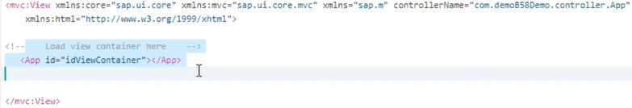

* A view should contain only one Page content, should not contain more than one-page content.
* In manifest.json file, under route view configuration, we need to maintain route view name as App view name.
  + - 1. In Web Application each web page is having different URL, which means part of the URL is different, that part is called as **URL Pattern**, constant URL is called **Domain name.**

Web application on empty pattern load the home page, based on the Pattern that page will load, this information giving to the application by routing.

**Basically, the router will do** based on pattern it will load the web page, mapping URL pattern to the specific web page is routing.

* + - 1. The Routing totally contains three sections which are.
* **Default value section**, which is executed only once when it’s executed the router body initialized.

We need to initialize the router in component.js. Like **this.getRouter().initialize();**

* **Routes section,** tell the target which view to load.
* **Target Section** load your view into view container.

No.of Routes = no.of Target = no.of web pages.

* + - 1. **clearControlAggregation**: means whenever a page is loaded into view container, there is another page demand for another page. Whenever second page demand has come, router load the second page in this case do you want to clear the first page or not.

SAP Recommends keep it false.

**Note: Beautify the code in SAP WEBIDE by ctrl+alt+v.**

1. **Back Navigation using router history:-7**

SAP Recommends back button should not create under view content, should create back button in page header level.

Until unless from which view, we came to present view then only we can go back, otherwise we can use router history.

**Router history:** which is provided by the library **sap.ui.core.routing.History,** the purpose of this library will store history of the navigation which means whenever we navigate to one page to another router will register an entry automatically in History.

Back button purpose in Realtime will be to go to the same page from where we landed up present page. Since it is same for any page in web application.

Instead of writing this back button code individual controller, we can write this code in component.js.

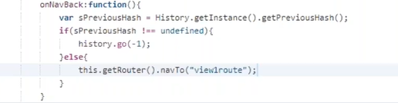

1. **Basic UI Elements of SAPUI5:-8**

There are four basic UI Elements apart from these there are many more UI Elements.

* **Text** - Used to display some text on output screen.
* **textAlign** property only work when **width** property used in Text UI Element.
* SAP Recommends maintaining as less as code in **style.css**, because at final all applications will sit in FIORI launchpad. Here all standard and custom applications are available, for customer point of view he likes custom application because which is color full applied by **CSS,** he may ask for standard applications but for standard we cannot apply custom CSS. Without writing code in style.css, we can apply the CSS by SAP given **standard CSS**.
* SAP fonts **-->** **sapMH1FontSize (H1s, H2 . . . H6).**



* **Input** - This will occupy complete width of the screen. To control this, we can use width property.



* **Button** - User triggers an action by clicking or tapping the button.

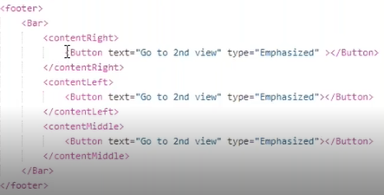

* **Label** - Used when we are developing forms, we need a label followed by some input.
* Label is always followed by some UI element (Input UI Element).
* SAP Margin -->**sapUiSmallMargin (Tiny, Small, Medium, Large),** when we apply this small margin, the Label will move little forward and come little down. (Means the margin will applied from left hand side and from top side).

To apply only little forward margin not down this is called **one side margin** by using **sapUiSmallMarginBegin (Begin, End, Top, Bottom).**

* This Label UI Element having **required property** if we set as true then in output we will get * on top of Label.



Every UI Element has three things which are

* **Properties** -
* **Aggregations** - If UI Element has inner parts, those inner parts are called as Aggregations.
* **Events or Actions ­**–

1. **Dynamically change UI Element Properties :-9**

Every UI Element is having properties on each property there is a **getter** and **setter** methods those are defined by SAP UI5.The getter method is used to get the value of property and setter method used to set the new value to that particular property.

**Ex:** If we take **Text UI Element** 🡪 getText () to get the text value.

setText () for set the new value to text.

🡪 set + property first letter capital

🡪 get + property first letter capital.

We should follow **camel naming convention** while writing the code in Java script.

**Exercise: 1-** get the input value and change the welcome text with Input value by submitting button in footer and disable the input field.

**Exercise: 1.2-** Extension to the above requirement, add one more input field with label alignment, when user click on button in footer, the welcome text must change with given first input value and based on the given second input value the welcome text alignment must be change. (**Left, Right and Center**)

**Exercise: 1.3-** Extension to the above requirement we need to add two more buttons with text hide all, show all. Along with 2nd Exercise functionality when click on Hide all button all UI Elements in screen should invisible and when click on Show all fields on screen should visible.

**Exercise: 1.4-** Extension to the above requirement, using only one button do hide all and show all UI Elements and button text also need to change based on flip.

* To get/set the Input value **-** this.getView().byId().getValue() / setValue();
* To get/set the text of Text UI **-** this.getView().byId().getText() / setText();
* To disable/enable an Input UI - this.getView().byId().enabled(false/true);
* To hide/Show the any UI Ele - this.byId().setVisible(false/true);
* For Text alignment of Text UI - this.byId().setTextAlign(“<Begin/Center/ Left>”)

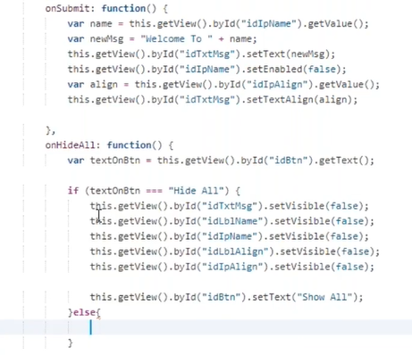

**Note:** If we want to display **page title center and Increased font size**.

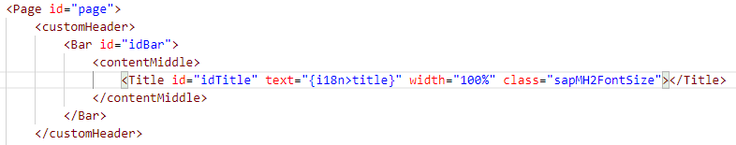

1. **Layouts- Grid Layout:10/11/12/13**

Screen designing using Layout’s concept in SAPUI5.

Layouts means arrangement of UI element in a specific manner, there are various layouts in SAPUI5.

**Types of Layouts:**

* **Grid Layout -** Most Important layout, reason is we can develop any kind of screen, the flexibility that grid layout gives us no other layout will give.
* **Simple Form layout** - name suggest, this layout is very simple design with labels and input fields.
* **Helper Layouts:**
  + **Panel -** Which is just a container, the panel will give us some features like header text, expandable, expanded.
  + **Vertical Layouts**
  + **Flexlayout**
  + **ObjectHeader**
  + **IconTabBar**
  + **Object Page Layout**

**Grid Layout:** Grid layout divides the width of the screen into **12 equal parts**, each part is called a grid.

Grid layout is part **sap.ui.layout** library while designing the grid Layout there is a property defaultSpan which means for every UI element inside the grid content how many grids we want to allocate.



Here **L** means for large devices and **M** means medium devices.6 means for every UI element inside content of grid allocates **6 grids**.

If we want to make **four column** designs in grid layout, we need to maintain the **defaultSpan** as L3 M3.For **six column** grid layout we need to maintain L2 M2.

**Exercise: 2.1**- Design Below screen shot using Uniform Grid layout and Apply **DefaultSpan Dynamically** by giving input in input filed and press the button.

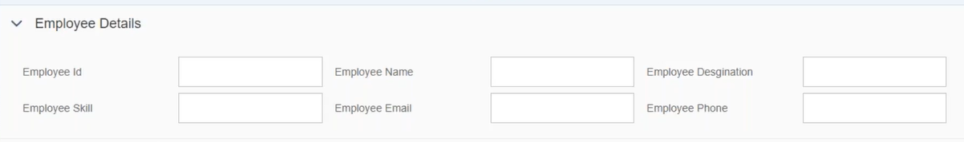

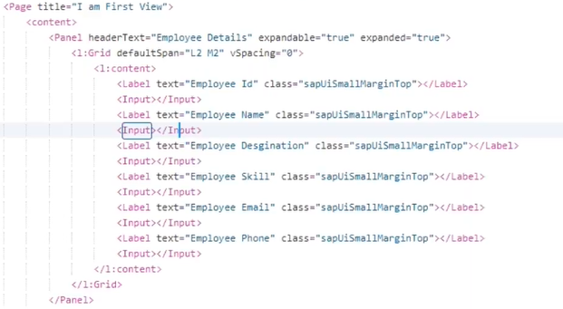

The above screen is uniformed design screens, most of the screens in real-time are like this. But some customers will ask zigzag called no-uniform screens.

**Exercise: 2.2**- Design the above screen shot using non-uniform Grid Layout.

If we want to design non-uniform (zigzag) screen using Grid Layout first remove **defaultSpan** from **sap.ui.layout.Grid** UI element and we need to apply at screen UI Elements.

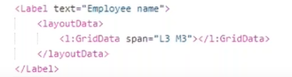

Any UI Element is not sufficient to fit in grid then it is wrap.

**SimpleForm Layout**: Which is part of **sap.ui.layout.form** library, which is by default coming with title property. Which is having **editable property** this will be **true** when we use label and input fields in simple form (this editable property for alignment purpose only) in label and input combination the simple form will give input height to label. If we use label and text property means, there is no fields to edit in simple form such cases editable property should be **false**.

In SimpleForm layout **right alignment** of the labels, left alignment is not possible, if user ask for left alignment, then we go with grid layout.

**Note:** **Don’t hardcode the input** width at input UI Element.

By default, the simpleForm will start from middle of the screen, to avoid this we need to apply grid concept by **layout property** of simpleForm and by applying the **labelSpan** the labels will occupy that many grids from left side, by applying the **emptySpan** that may grid will be empty from left side. If we want to decrease or increase the input width by applying the emptySpan.

**Exercise: 3.1**- Design the Employee Details using SimpleForm, and apply **EmptySpan dynamically** by giving value in input field and press the button.

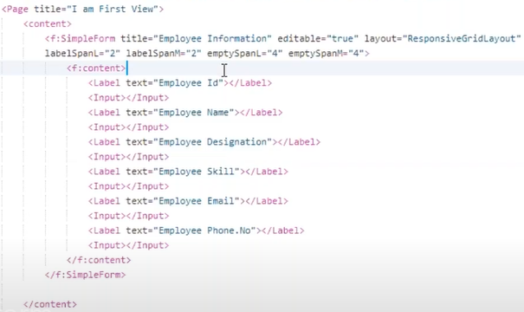

If we want to do simple form as subgroups by using **transparent container**, here the title itself will create a container. This is part of sap.ui.core library when we use **<sap.ui.core: Title>** sap ui5 understand that he needs **transparent container**.

If we want simple form two subgroups side by side, then the **emptsySpanL/M = 0** and **columnsL/M = 2**. If we want simple form two subgroups one under the other, then **columnsL/M = 1** and **emptsySpanL/M = 3**(depend on requirement the emptySpan value will change).

**Exercise: 3.2**- Design the Employee Details using SimpleForm and Transparent Container and apply **ColumnSpan dynamically** by giving value in input field and press the button.

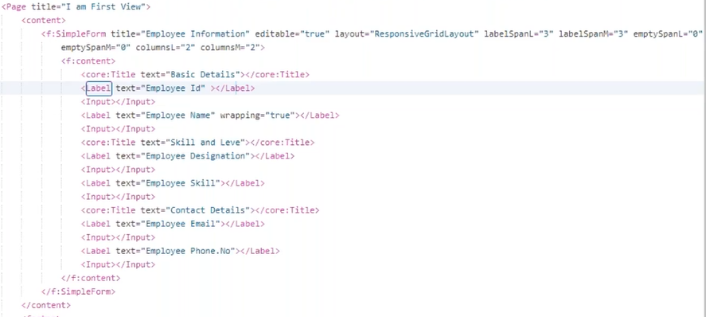

**Helper Layouts:** These are not main layouts and help you in main layout. Below is the small part of the layouts, we have this HBOX it is a responsive horizontal layout and VBOX it is a responsive version of vertical layout.

**HBOX**: which is horizontal box, whenever you want to arrange the content in horizontal. If we want to arrange the UI elements one side the other.

No gap between the UI elements in HBOX, if we want to maintain the small gap, we need to maintain the margin class property on HBOX.

**VBOX**: Which is reverse to HBOX, if we want to arrange the UI elements one below the other.

There is a small gap between the UI elements under VBOX.

When we open our application in Launchpad, the UI Elements are looks little compact compare with developed application in development tool (WEBIDE/BAS). To get the same look as launchpad in development time we need to apply **compact density at app.controller.js**.

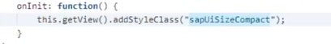

**Exercise: 4.1-** Design below Screen shot search Products with HBOX and VBOX.

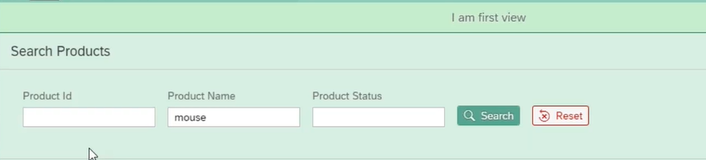

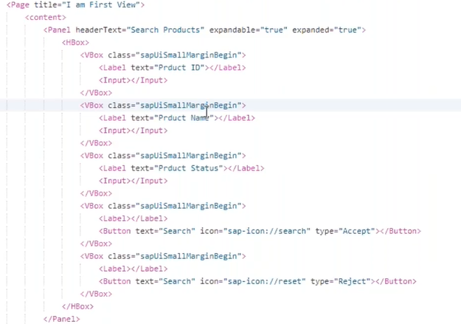

**FlexBox:** is also called as flexible layout or flexible box, we can use it in two scenarios.

Scenario1🡪 If we want any UI element (except text) to arrange at begin, center, end of the line. Why except text because we have textAlign property in text UI Element to arrange the text at any place.

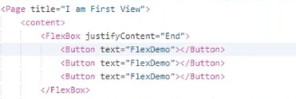

Scenario2🡪 If we want to keep content at the center of the page, normally we don’t get this requirement in Realtime.

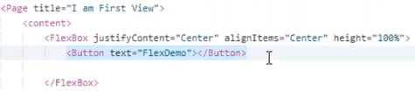

**Note:** For login page we won’t apply compactsize style class.

**Exercise: 4.2-** Design the Login screen using the **Flexbox**. But in Realtime we don’t design the login page.

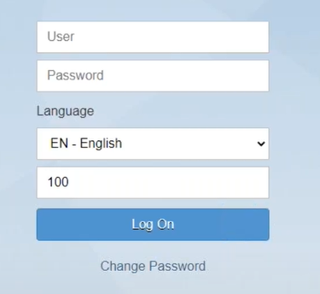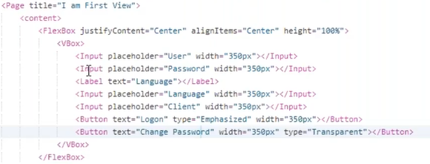

**Note: Evaluation of themes in SAPUI5 are:**

Sap_bluecrystal **–** this is the first theme

Sap_hcb – high contrast black for visually challenged people.

Sap_belize **–** in 2016 this theme is introduced by SAP which is combination of sky blue and grey color combination.

Sap_belize_plus – for dark version of sap_belize.

Sap_fiori_3 **–** In 2019 version 1.8 and above for light color introduced.

Sap_fiori_3_dark –

**ObjectHeader** and **IconTabBar:** these two are different layouts but we will use them combinational. **ObjectPageLayout** is simply replacement for ObjectHeader and IconTabBar.

Why we need to use ObjectHeader and IconTabBar combindly, because ObjectHeader is for **main/Header** information and IconTabBar for sub **information/item** information.

**IconTabBar** is a container we can keep any content inside. This IconTabBar can contain any number of iconTabFilter.

Default the first iconTabFilter will open, if we want to open other than first, we need to pass the key value to selectedKey property of IconTabBar. (Here the key value is from key property of iconTabFilter).

**Exercise: 4.3-** Design as below using **ObjectHeader, iconTabFilter**.

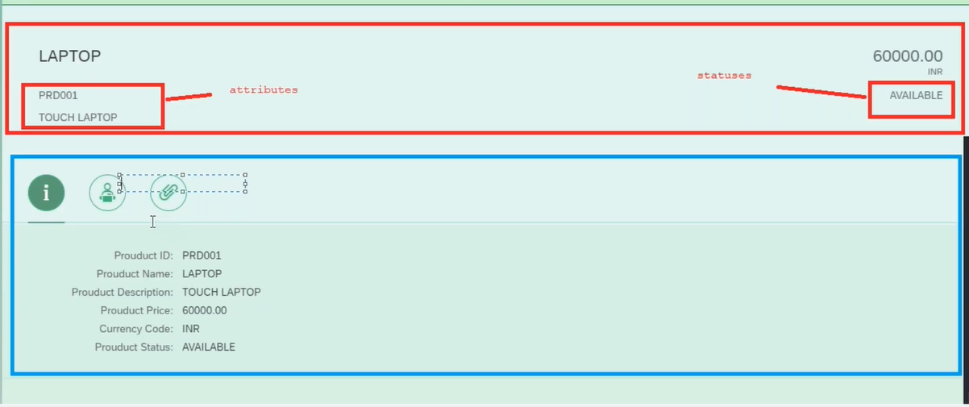

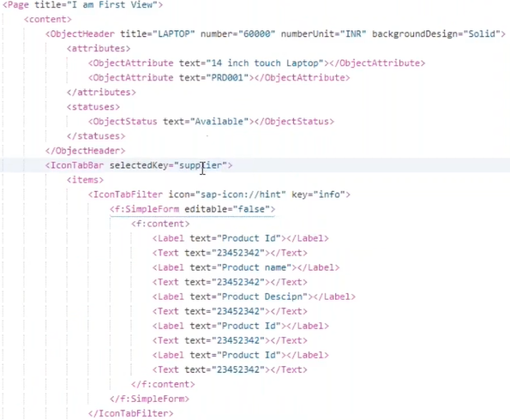

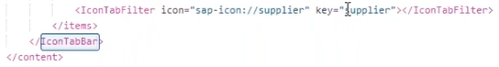

**ObjectPageLayout:** which is the replacement of ObjectHeader and IconTabBar, but the purpose is same. This UI element is part of the **sap.uxap.**

In objectPageLayout the tabs are called as sections. In iconTabBar we can keep icons **whereas in objectPageLayout we cannot keep icons** we can write only text.

By default, this text will come in uppercase, if we want to make it off by a combination of property **titleUppercase=“false”** in ObjectPageSection and **uppercaseAnchorBar=”false”** in ObjectPageLayout.

**Exercise: 4.4-** Design the above same thing in **objectPageLayout**.

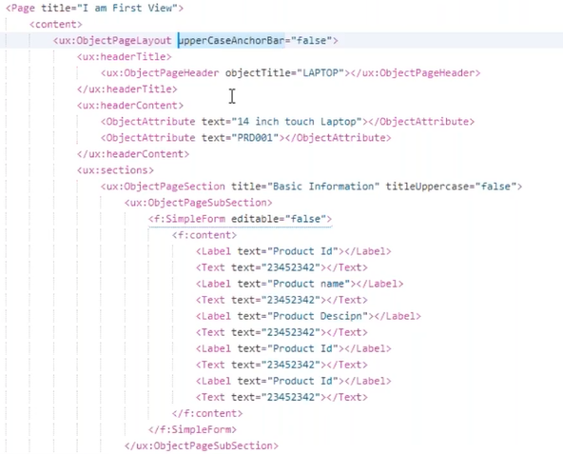

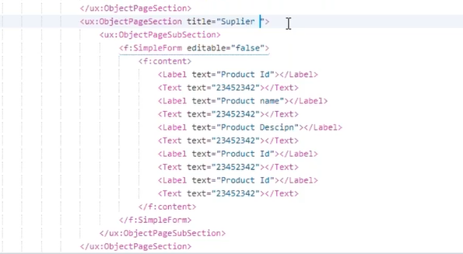

1. **Validations: 14**

Each and every screen will have validations, we can perform these validations in view controller. These validations are categorized as two, which are.

**Mandatory validation:** We can perform the mandatory field validation; we turn the border of the input field as red color and show the message with red color saying that this field is mandatory.

To maintain the input field as mandatory then we need to use **required property** in Label.

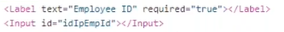

To check either required field is empty or not, if it is empty then show border as red and message.

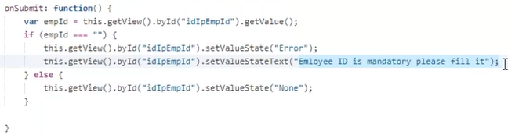

**Data validation:** whatever the data entered by the user in input fields, we need to check either it is valid or not. Here data validation has two parts.

* **Data format validation** 🡪 it will check data format.

The data format will check against numeric validation, length validation, alpha numeric validation, and email validation.

Numeric & Length validation: should be only numbers (0-9) and it should be of >=8 digits only.( /^[0-9]+$/ ).

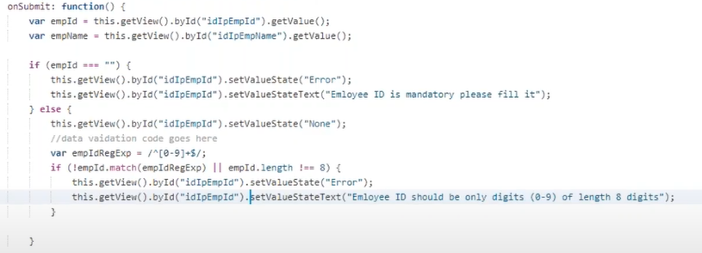

Alpha numeric validation: The input field should be a alphanumeric of max length 30 characters.( /^[0-9a-zA-Z]+$/ ).

Email Id validation:



Phone number validation: here we have to maintain **maxLength** property is 10.

* **Existence of the data 🡪** either data really check or not in back-end.s

**Exercise: 5**-Design above mentioned validations in single Application.

1. **ODATA Introduction:15**

Our front-end development is combination of XML and JAVA Script, and back-end development is with full of ABAP. Front end will not understand any object in back end.

If we want to send the request from front end, to create a record into back-end database table we need a mediator is called ODATA.

**Data flow between Front-end to back end**.

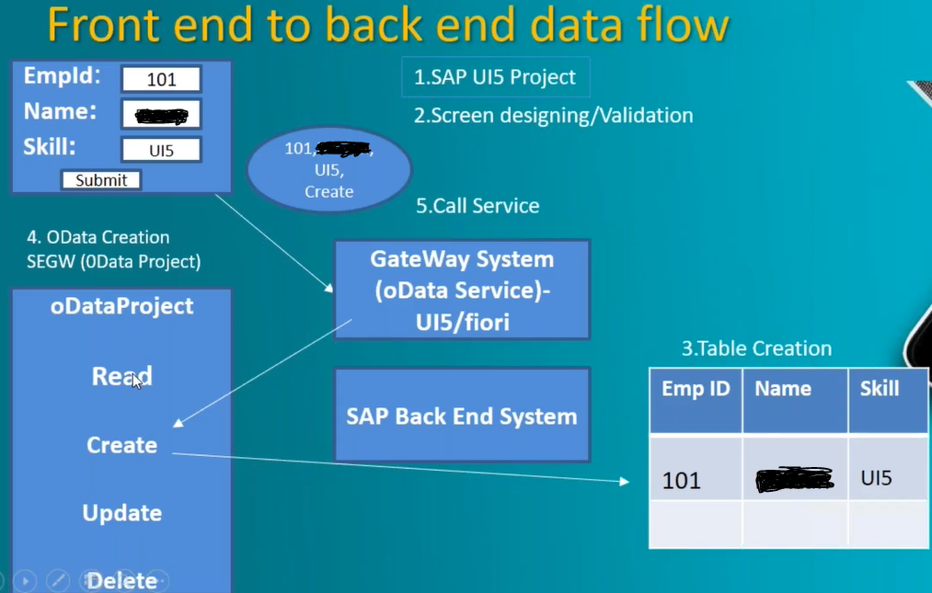

In Realtime the development of front end and back end will happing parallel.

**Step1:** Develop the tables in back-end system.

Products Table:

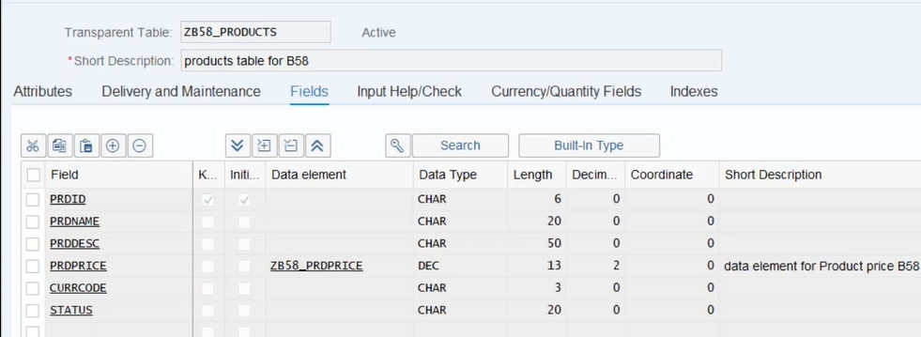

Suppliers Table:

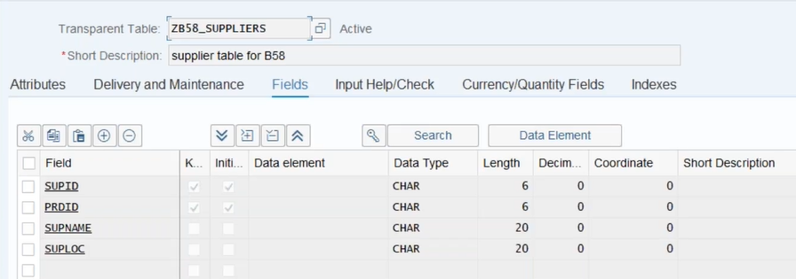

**Step2:** Create ODATA Service in SEGW.

In ODATA Service, we have below parts.

**DATA Model:** Means modelling the data in such a way that, which creates the interface between front-end and back-end. Interface is nothing but mediator between front-end and back-end.

Within the DATA model we have three things.

* **Entity type 🡪** this defines the collection of fields to carry the data from front end to back end.
* **EntitySet 🡪** Which is like internal table, this can store collection of records.

Entity type and entity set have 1:1 relation.

* **Association 🡪** Defines the relation between entity and EntitySet.

**Step2.1:** Create the ODATA Service in SEGW Tcode using above Custom database tables.

While generating the ODATA Service, it will generate the **two classes** those are **model provider class** and **Data provider class**.

**Note:** Whenever you know the ODATA project, but you don’t know the ODATA Service then by ODATA service is **<ODATA_project>_SRV**.

**Step2.2:** After creation of ODATA Service we need to deploy into **Gateway system** using /**IWFND/MAINT_SERVICE** Tcode. Here we can select our OData service and press on call browser then it will get the ODATA service in browser.

1. **ODATA Runtime artifacts and Query Operations:16**

Explanation of the ODATA Service URL.

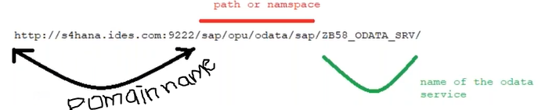

At the end of the above URL by adding $metadata, we will get metadata of the ODATA service.

This metadata will give us complete information of ODATA which are what the entities are, entitySet’s and associations are created.

In metadata if search for **Entitycontainer**, here we can find the how many entity’s and entitySet’s are available.

**ODATA CRUD Operations:** Normal ODATA protocol having four CRUDQ Operations (Normal ODATA protocol CRUD Operations are four).

* **CREATE 🡪** Is to create a single record (CREATE_ENTITY).
* **UPDATE 🡪** To update a single record (UPDATE_ENTITY).
* **READ 🡪** To read a single record (GET_ENTITY).
* **DELETE 🡪** To delete a single record (DELETE_ENTITY).
* **QUERY 🡪** This query operation works on multiple records, remaining above operations work on single record (GET_ENTITYSET).

If we want to create a greater number of records like 10 or 100 then this is called as **batch operation.**

**DPC_EXT class:**  Which gives the provision to data provider logic, which generates the 5 set of methods for the CRUD Q for each entity.

**MPC_EXT Class:** based on entity it will give you access to those entity’s and this class readily provide data types.

1. **Connecting ODATA service to WEBIDE, Calling query operation:17**

If we want to connect SAP WEBIDE/ BAS to SAP Gateway system, then we need to maintain the destinations in SAPWEBIDE cloud/ SAP BAS cloud.

In SAP UI5 there are **four models** are available to perform data related operations. Each model has different purpose. (XML Model which is not used in Realtime).

* **ODATA Model 🡪** This is an object; this connects to system ODATA service, and it can call for CRUD operations. The creation of model in SAPUI5 of manifest.json file🡪model is as below.

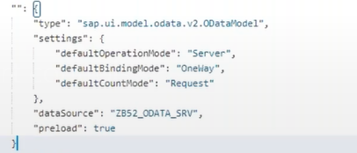

* **JSON Model 🡪** Which is local memory or runtime memory, this can store static data or coming from the back end.

SAP does not recommend us to pull the back-end data and store in json model. Because this will reduce the performance of application.

JSON Model can store the back-end data, but json model does not pull the data from back-end.

* **Resource Model🡪** which is automatically created at the time of project creation using template. This model points to language translation.

**Exercise: 6.1**- Design a Table to display above created ODATA in front-end.

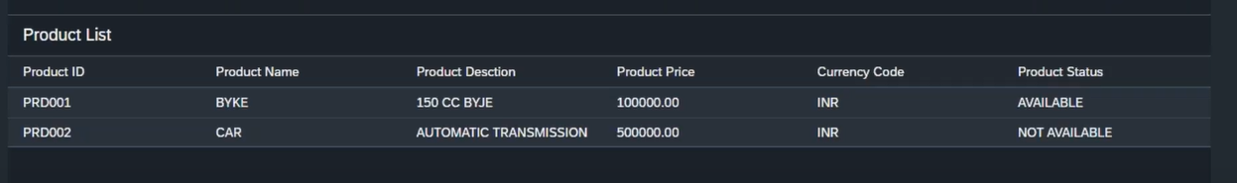

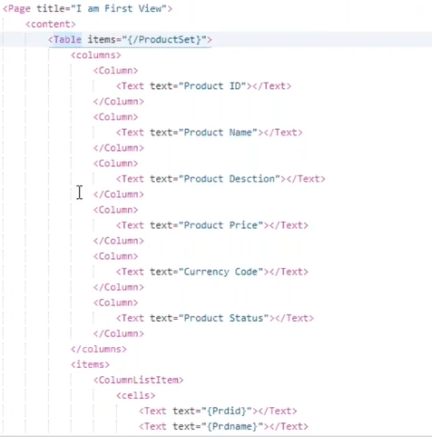

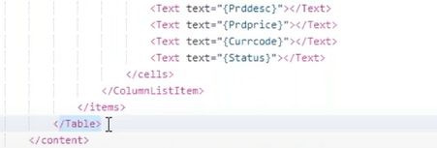

1. **List and MultiValue UI Elements:18**

**List** and Table UI elements are both are used to display multiple records, the difference between them is presentation. Table is collection of columns and rows whereas list is collection of list items.

Table is collection of **ColumnListItem** whereas List is collection of **ObjectListItem.**

**Exercise: 6.2-** Here we can display the ODATA model data using List in front-end.

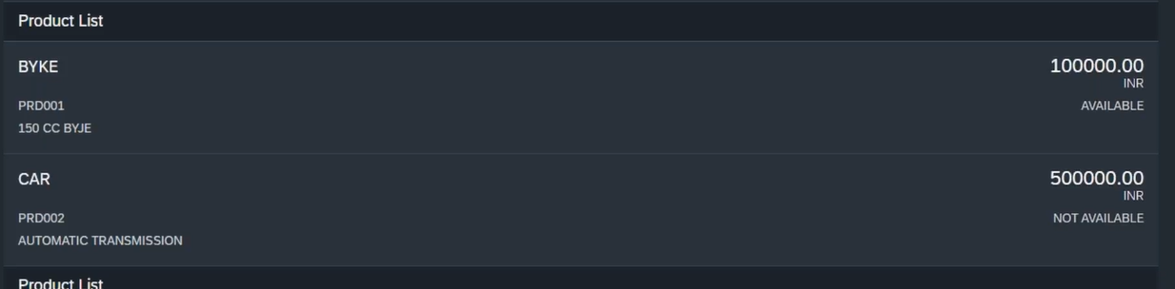

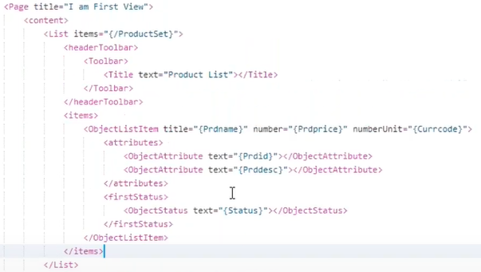

**MultiValue UI Elements:** any UI element can store multiple values which are

* **SelectBox**
* **comboBox**
* **multiComboBox**
* **radioButtonGroup**

**Note:** the table and list are coming under composite UI Elements.

In above MultiValue UI Elements binding with ODATA aggregation is not suggestable, because those are having duplicate records, **duplicate records** displaying in dropdown, comboBox and multiComboBox is not suggestable .we can achieve to avoid those duplicates by two ways.

* One is creating another entity to avoid the duplicate records.
* In real-time pulling these values from back-end (using separate entity) is not suggestable, so we can maintain these values in front-end using **JSON Model**.

**Note:** In Realtime we use mostly **comboBox instead SelectBox.**

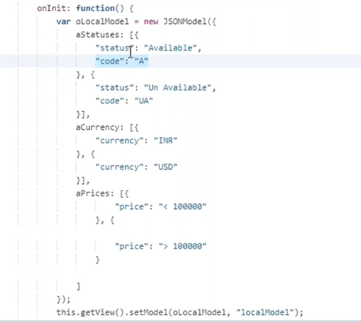

The SelectBox Design in XML View as below, in SelectBox by default one value will be selected, based on that value output must come. In Realtime because of that instead of this SelectBox we use comboBox.

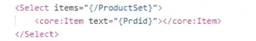

**Exercise: 6.3**- Based on user selection, the above table data must display as per search, for that design a Search Options like below screen shot using SF, transparent containers and MultiValue UI elements.

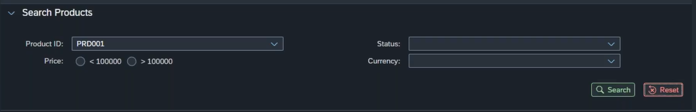

**Note: 1.** to make two radio buttons come in horizontal by a property is **columns of RadioButtonGroup UI Element.**

**2.** By property **selectedIndex = “-1”** in RadioButtonGroup UI Element none of the radio button will select by default.

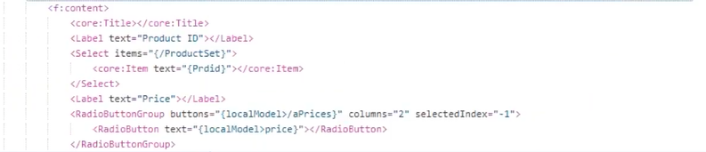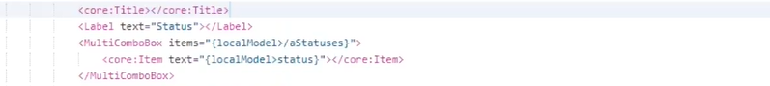

1. **F4 Help Implementation using fragments and dialogs:19**

To get the F4 Help button at the end of the Input field, we need to pass **true** to **showValueHelp** property.



Whenever we want to create a dialog in SAPUI5 we will be using **combination of fragments and dialogs**.

**What are the fragments and dialog:** Actually, to create a popup dialog we need only **dialog** UI element not fragment? We may have same input F4 help in some other views so we don’t want to write the same code in multiple places so to avoid this we will use fragments.

**Fragments:** which is a lightweight view, and it is used to keep reusable part of the views.

**Note:** The fragment file should contain the extension of **fragment.xml**.

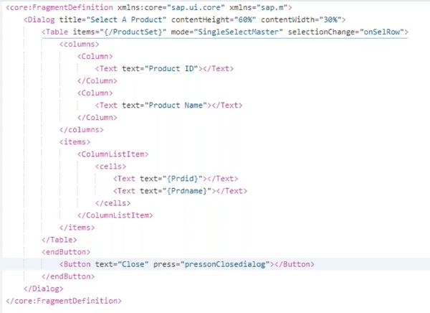

**Note:** In JavaScript we have **two ways to declare a variable**, which are as below

var name = “Sridhar”;

this.name = “Sridhar”;

The difference between these two and when to use them. Whenever we declare a variable with **var** that will be applicable within that function (block), if we declare using **this**. That we can use in any function (Block).

**Note:**  view ID is itself fragment ID.

When user click on F4 help then dialog open with fragment and if user click on any value that value has to come and sit in input, that logic is as below.

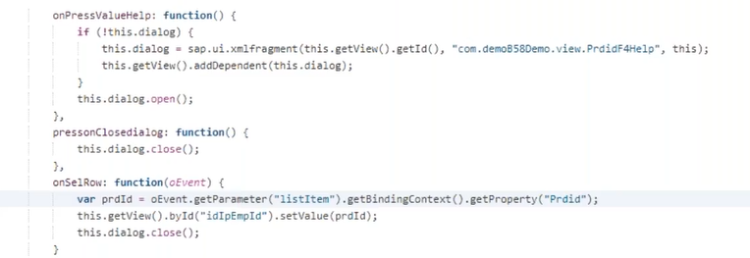

**Q:** **Why the dialog makes dependent of View?**

When we make our dialog is dependent of view, then only model (any model) will be applicable to that dialog.

**Binding Context:** which is an object, and this object pointing to sub path of the binding and this entire sub path representing a table row.

Whenever we want to read any value from the selected row of table , we need to bring binding context of that row. Because the binding context can hold values of that row.

**Exercise: 6.4-** Apply F4 Help to Product ID with **fragments** in above search option screen shot and create two Buttons with the name of search and reset at bottom right corner.

If we want to place two buttons at the right-side bottom corner of Panel UI Element, we need to use FlexBox UI element.

From above logic screen shot, after the SimpleForm we can write logic as below.

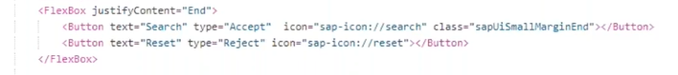

1. **Applying Filters Back-end Part:20**

From the above search products, if user will apply search options, then based on that search below table has to filer and get those related records.

When user clicks on search button below logic will trigger in controller.

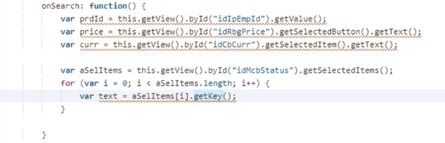

We need to send this filter to back-end system through ODATA URL, and we will get these filter values in ODATA service **GET_ENTITYSET method** by the parameter called **IT_FILTER_SELECT_OPTIONS.**

This **IT_FILTER_SELECT_OPTIONS** has two columns which are property and select-options.

When we hit the below URL from SAPUI5 for filter the backend data based on one filter which is Prdprice.



**Exercise: 6.5**- Apply **Filters to back-end OData service** based on above search options given by user from front-end.

The IT_FILTER_SELECT_OPTIONS will fill like below in GET_ENTITY set method of ODATA Service.

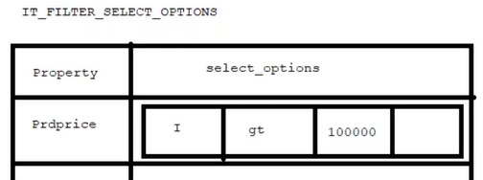

We can apply multiple filters based on customer requirement; he will apply multiple filters to search the data based on filter he applied. The multiple filter URL is as below.



Once the IT_FILTER_SELECT_OPTIONS is filled with filter values, then based on this table we need to write the below logic at GET_ENTITYSET method of DPC_EXT class in ODATA service, so that we can get the filtered values in SAPUI5.

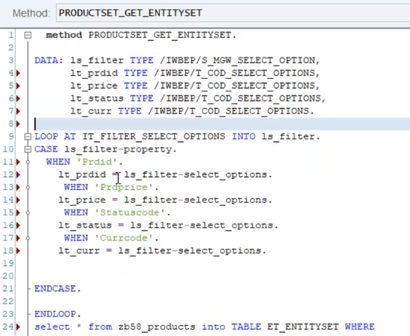

1. **Applying Filters from Front end:21**

We need to construct the URL dynamically from SAPUI5, to construct the URL we have a library **sap.ui.model.Filter.**

Internally in runtime below statement will convert as URL to filter the data from Back-end.



From search Product screen shot, if user click on search button below particular function code will trigger in controller.

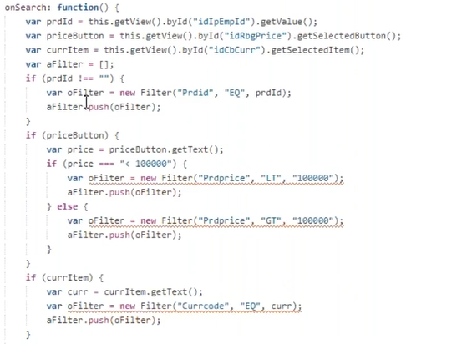

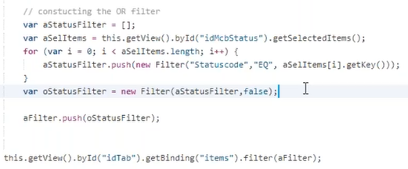

**Exercise: 6.6**- Apply **Filters to Front-end FIORI application** based on above search options given by user.

1. **Sorting:22**

Here we can sort the any column of a Table. How the sorting will be done, first we will see the sorting at ODATA Service.

The URL to sort the ODATA service is as below.



Based on any field from table we can do sorting, only the field has to be changed in below URL

**?$orderby=<fieldname> asc/desc**

If we have given an URL with Sort (orderby) then **IT_order** parameter will fill in **GET_ENTITYSET** method. And this IT_order parameter is having two fields which are **property and order**.

Below logic we must write in GET_ENTITYSET method to get the functionality of sorting .Declare these three first in method.

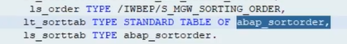

After declaration we need to loop the IT_ORDER table and apply the sorting to ET_ENTITYSET table.

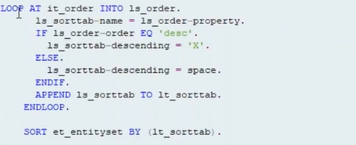

Now we will see the sorting at front-end SAPUI5.

**Exercise: 6.7-** Design the one more filed **Sort by** in search product screen shot as below and apply the Sorting in back-end OData and Front-end Application .

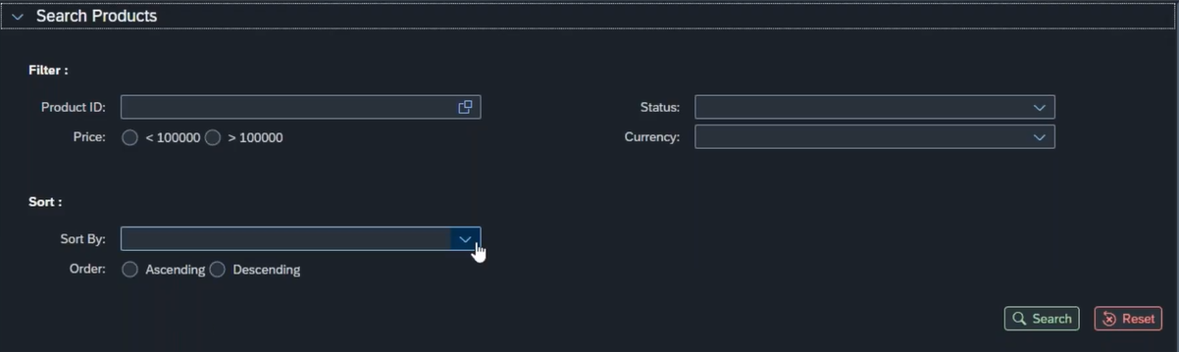

Define two arrays for sort fields (what are the fields we want to include for Sorting) and sortOrder and set the JSON Model in controller corresponding view and apply this to comboBox.

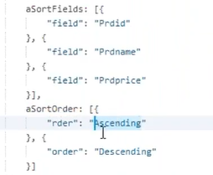

Design the comboBox (sort fields) and radioButton group (sortOrder) in view and apply aggregation binding.

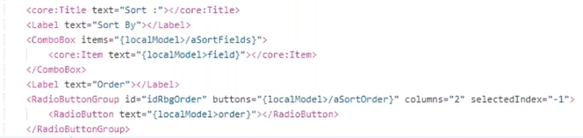

After selection of sorting and press on apply button, below logic will trigger in controller, so that use will get sorted records as per his selection.



The sorting function will apply to model using the library is sap.ui.model.Sorter, we need t to maintain this -

Library in scaffolding template with name space as Sorter.

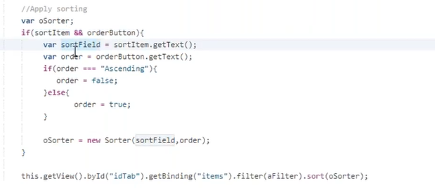

Reset Functionality when user click on reset button, whatever the fields we have applied for filter and sorting, those fields and long with those fields table also should reset.

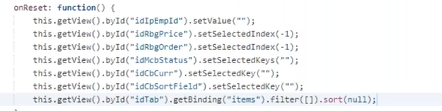

1. **Formatter and ODATA Read Operation: 23**

**Formatter:**

**Exercise: 6.8-** We will explain the formatter, by making Product status if available make it as green color, and not available make it as red color.

From above table XML logic, replace the status column Text UI element with **ObjectStatus** UI element by default it will not change the status with colors, we need to fill the state property.

If we pass **Success** to **state** property, then it will give **green color**, whereas if it is **Error** then it will give **red color**.

To pass the dynamical value into state property of ObjectStatus UI element we should use formatter which is JavaScript file.

In formatter file we need to write the below logic.

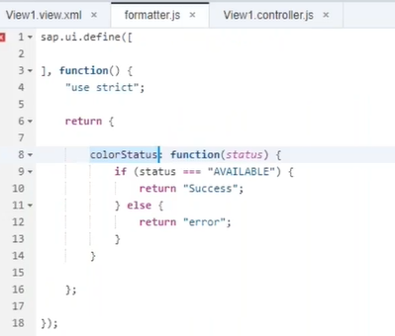

We need to call this formatter from UI Element in XML View. Any view can call that respective controller, but formatter.js is not view controller so we need to include this formatter in view controller as below.

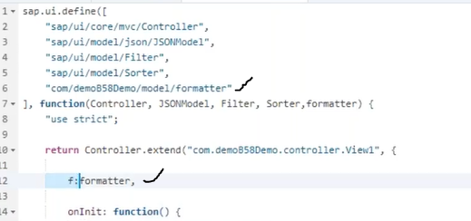

Calling formatter from View is as below.

In above formatter calling logic the initial .(dot) means to make the view to refer to its controller then it will goto controller and find the f , it understands the f means formatter then it goes to formatter then the function will execute and return the value.

**Note:** Why we have not wrote this formatter functions in view controller, because for reusability which means any view can call their own view controller so we have mention formatter functions in formatter file we can call this function from any controller.

**ODATA Read Operation:**

This read operation will execute the **GET_ENTITY** method, the URL from browser to get the single record based on value of key field is as below.



The logic in GET_ENTITY method is as below.

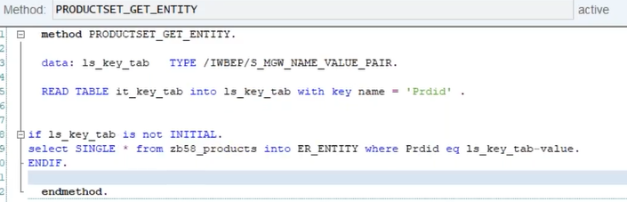

1. **Element Binidng:24**

**Exercise: 6.9-** When user click on any row of the above table it will navigate to next view and display selected row information in ObjectHeader and IconTabBar (SimpleForm).

**Syntax of Bind Element - <modelName>/productSet (productid)**

To make table rows navigable, we need to mention **type** property in **ColumnListItem** UI element and event **Press**, by mentioning the **Navigation** in type property we will find the arrow symbol on each record of the table. In XML view the logic is as below.

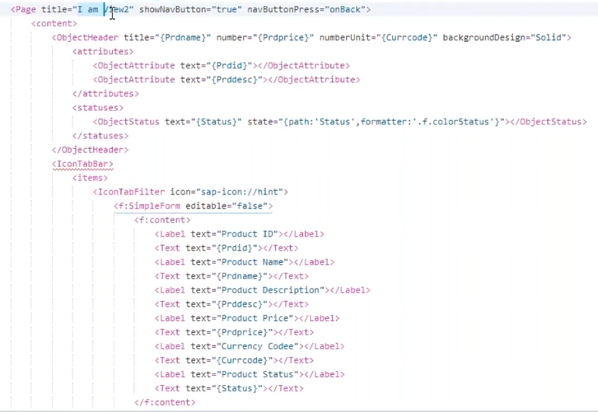 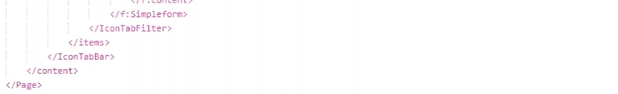

When user click on any record then the press event will trigger and respective function will execute, the function code in controller is as below.

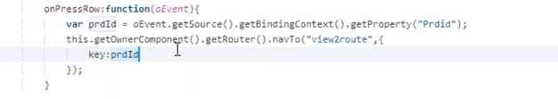

Here the router navigates to next view along with the parameter Keys, in key we will pass the selected Product id value. To pass the product id value along with router we need to configure the route as below.

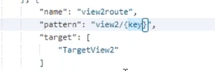

In first controller we need to read the selected record and pass the productid (key field) to second controller. In second controller read the productid and call the URL.

If we write the logic in onInit method, it will execute only once when this controller executes very first time, but we need to execute the bindElement every time when user select on table record in view1. In such case we need to write the logic attachPatternMatched in onInit method as below.



In above logic we are executing the function **onPatternMatched**, whenever the 2nd view pattern matches in URL, which means the whenever user select the record, its navigating to next view on that time it will check the pattern of URL if that pattern matches the 2nd view pattern, then above method will execute.

In **onPatternMatched** method we need to receive the parameter which we have sent along with router from view1, the method login view2 controller as below.

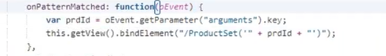

In view2 the logic as below to print selected record from view1.

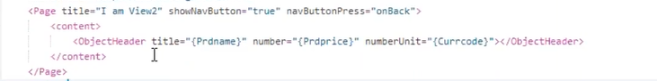

**Types of Bindings:**

* Property Binding 🡪 is also called as single value binding, **ex:** whatever the binding we have done for title or text are property binding?
* Aggregation binding 🡪 if the binding is done against the aggregation of UI element, this binding is always point to collection of values.
* Element binding 🡪 Element means one single item, whenever we want to send the single item to other view then we will use element binding.

1. **Associations:25**

SAP application will run in BAS in **node.js** environment, the folder **node_modules** contain run time different models of node.js.

**Exercise: 6.10**- Extension to the above example need to add one more **iconTabFilte**r for product suppliers with table UI Element.

Why we need to create the **Associations**, for example if user click on any one product, then that particular product suppliers we need to get, for this reason we should have an association between those products and suppliers.

In any ODATA service metadata we can find what are the associations are exist and those navigation properties.

If we want to navigate to suppliers from **productsSet_get_entity** method using **navigation property,** the browser URL is as below.



The logic in **suppliersSet_get_entitySet** method is as below.

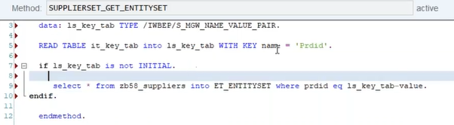

The logic for new iconTabFilter to display list of suppliers in XML View for selected product is as below.

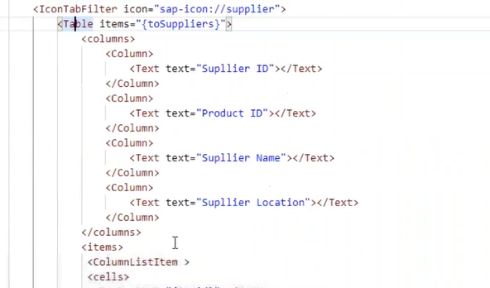

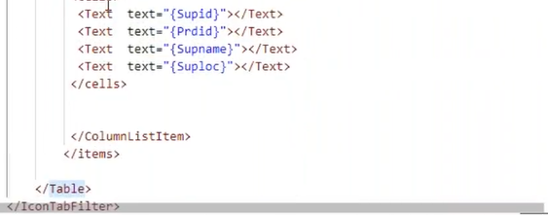

If we want to get the product data and its respective suppliers’ data in single request- the browser URL is as below.



From SAPUI5 we can get the product and suppliers details in single request which logic is as below.

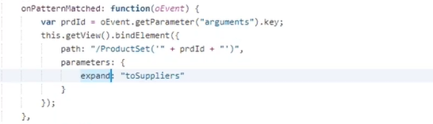

1. **Create Operation end to end: 26-**

**Exercise: 6.11** -Design **Create** button in footer of the previous screen when we click on it, the screen will navigate to below screen to create new products in back-end.

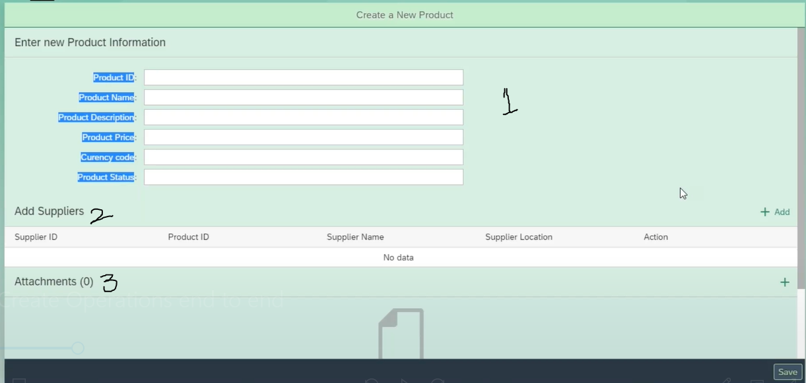

The logic to design the above part -1 of the screen as below.

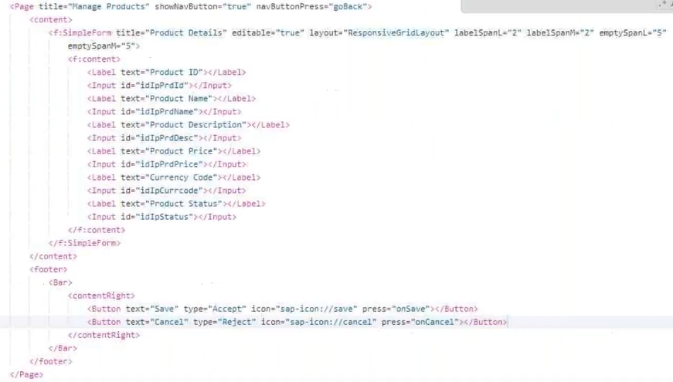

To hit the **get_entity** or **get_entitySet** method we need to pass those operation names in URL, then it will directly hit those methods. But to hit the **create_entity** method we need to pass the operation name and products data along with URL as below.

The below URL go and hit the **productSet_create_entity** method.



When user click on **save button**, we need to read those product input field values first.

After reading all those values, the data which we want to send backend, all those data must be present in **JSON structure**. The data we called as **payload**. To call any **CUD operation** we need object of ODATA model.

Then using this ODATA model we must apply create operation to create the data into backend system here we must apply success and error messages to get the status.

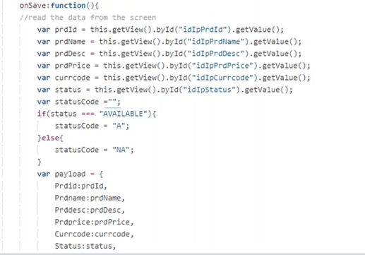

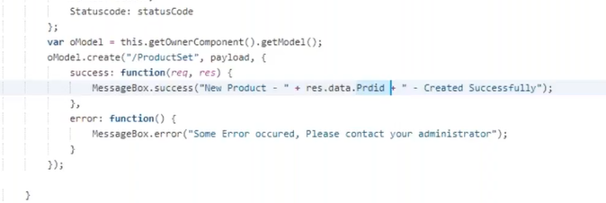

Now we need to implement the **ProductSet_create_entity** method in ODATA Service in Back-end System to insert the record into database table (which is coming from Front) the logic is as below.

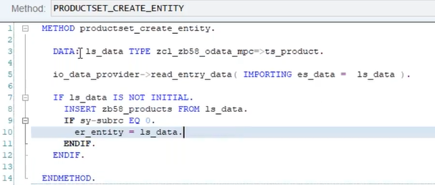

We need to send the status either the record created successfully or not from back-end to front-end, to capture the response in front-end SAPUI5 application we need to use two parameters in success function which are **res** and **req**. Here **res** to get the response from front-end and **req** to send the request to back-end.

1. **Update and Delete End to end: 27-**

**Exercise: 6.12-** Extension to the above project, keep two buttons with **Edit** and **Delete** names in footer of the page, when user click on Delete the product should delete straight away, if click on Edit this product information populate in form with label and input fields where the user can edit the data when he clicks on save then the product information will save.

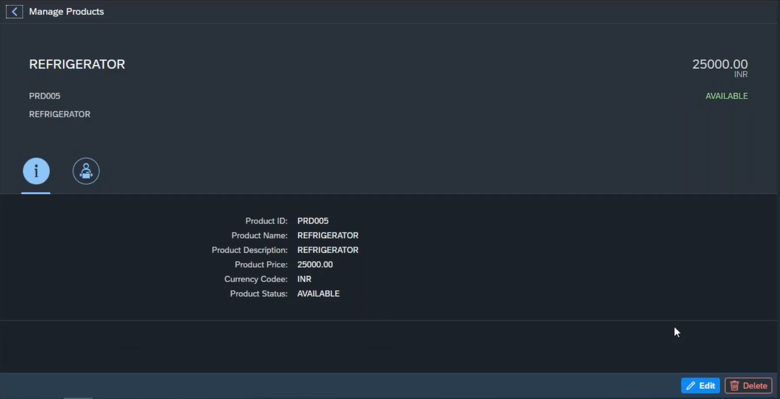

In design wise there is two possibilities to edit the product info, we can populate a popup and display this information in edit mode, or we can navigate to another view and display in edit mode.

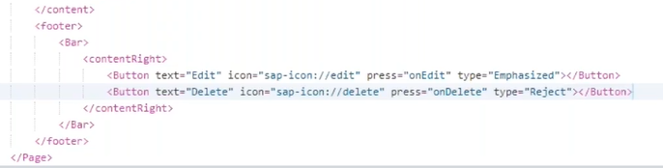

When user click on edit mode, here we are going with edit the data in new view. When user click on Edit button, we need to navigate to next view to edit the product information.

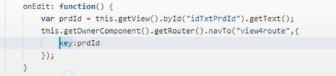

In next view we need to capture the product ID in **routePatternMatched** method and using **bindElement** apply to view.

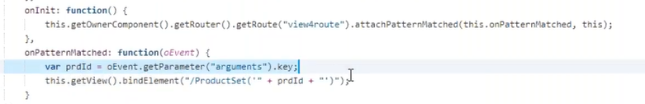

And design the SimpleForm in next view as below.

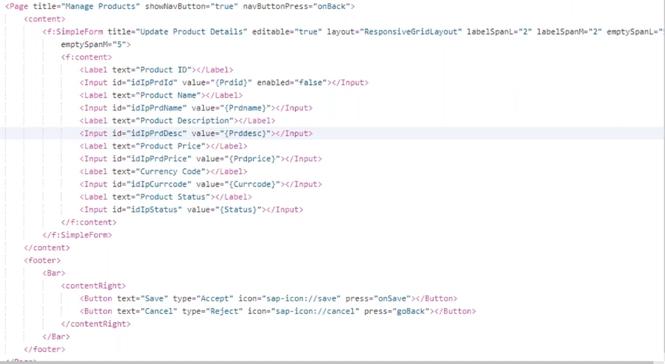

When user click on save button, the data which is edited should update in back-end.

**Note:** ODATA service URL for Update Operation we don’t have a **request** property, we have only **response** property.

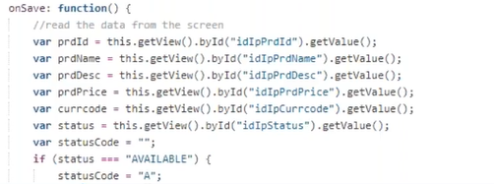

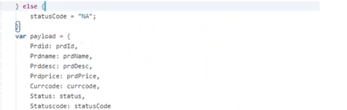

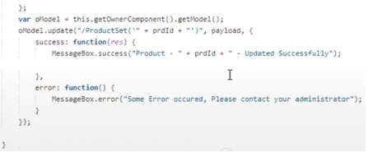

**Note:** In Update method we need to pass the **product ID** which we are going to update in back-end.

We need to implement the **ProductsSet_update_enity** method of ODATA service in back-end system.

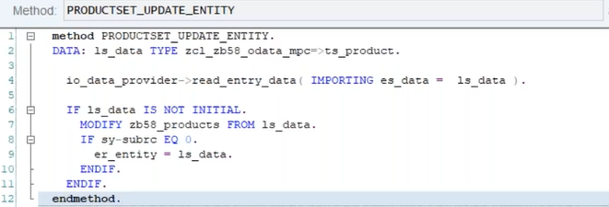

When user click on **DELETE** button, we need to pass the primary key of the entity to delete the data in back-end system.

**Note:** We don’t need **payload in remove operation.** In place of remove if we **use delete**, our ODATA model will be deleted.

We need to send the **confirmation popup** when user click on Delete button.

If user click on OK we need to delete the Product information in back-end data-base table using **remove operation**, the logic is as below.

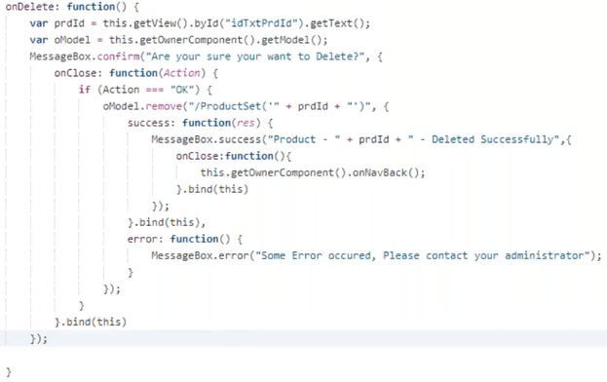

In back end we need to implement the **productset_Delete_entity** method of ODATA service, and the logic is as below.

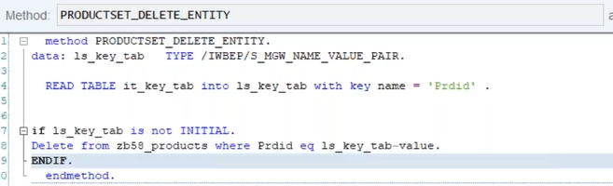

1. **Create Deep entity Front-end: 28-**

Here front-end part of the create deep entity. Whenever we create a child record along with parent records, the create deep entity concept coming into picture.

**Examples:** create sales order along with its sales items.

**Exercise:** **6.13**- Extension to create new products, to add supplier’s data design like below screen.

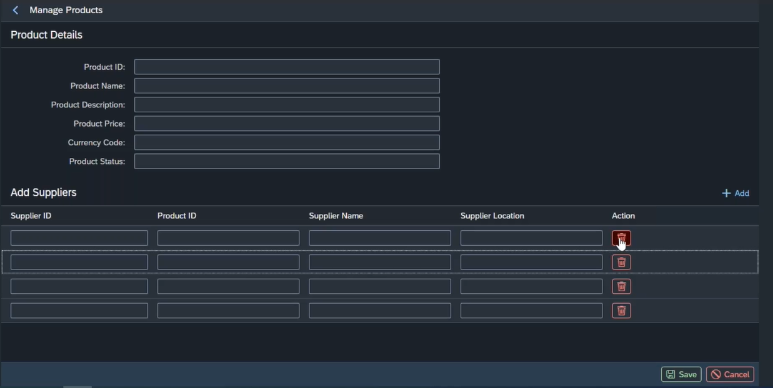

Below logic to design the above screen shot in XML View.

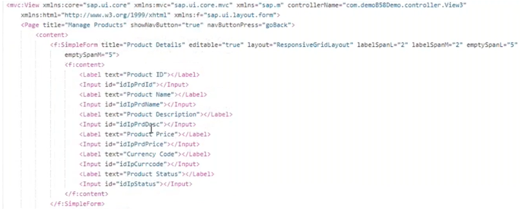

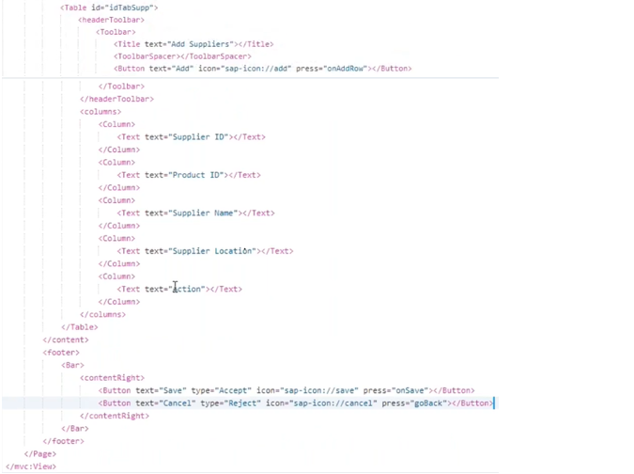

When user click on Add button on suppliers table header, a new empty row will insert in the same table, as many times if user click add button that many rows will insert into table.

If user want to delete any row, he can be able to delete any row by pressing the delete button under action column in that particular row.

The logic related to add new item into suppliers table and delete any row using delete button from the same table.

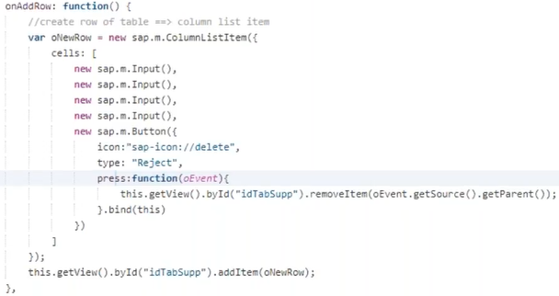

**Note:** The payload for create a deep entity will reach the back-end system through navigation property which is act like a carrier for array of a multiple child data.

When user click on save button, we need to send the deep entity payload with **create** operation. The logic is as below.

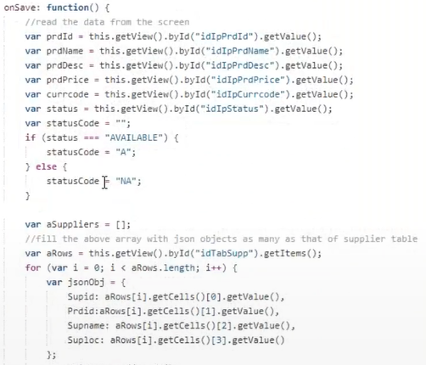

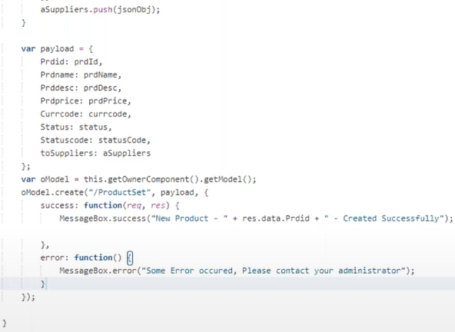

**Note:**  Like create deep entity for creation of header and Item details at a time. If we want to delete the header and item at a time we need to write the logic in **DELETE_ENTITYSET** method to delete header and item (if those two tables having relation). If they don’t have the relation, then we should write the logic to delete those two tables in **CREATE_DEEP_ENTITY** method only.

1. **Create Deep Entity back-end:29-**

To write the logic in **create_deep_entity** we don’t have standard deep structure, so we need to create our own deep structure in **MPC_EXT** class as below.

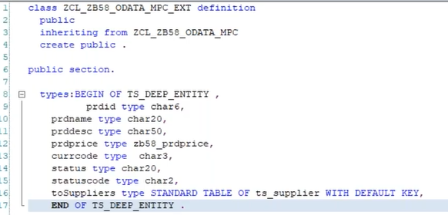

In DPC_EXT class we need to write the logic in **CREATE_DEEP_ENTITY** method to get the data of master along with its details.

Define one work area with our own structure defined in MPC_EXT class.

Once the data creation is completed, we need to send it back to front-end.

**Note:** In payload table field name (Deep Structure name) should be same as navigation name. In back end the structure which we have created in MPC_EXT class the table field name also as navigation name.

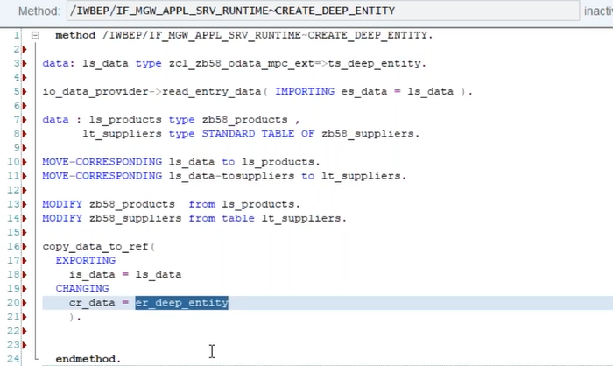

1. **File Upload and Download:30/31**

**Upload Attachment:**

The multiple attachment we can give using UI Element is **UploadCollection/****UploadSet**.

First, we need to create Database table to store these attachments, this table having some fixed number of fields.

The file content will store in file content field with **hexadecimal format**.

**Exercise:6.14-** Extension to above screen, add UploadCollection under suppliers table, user can able to add files and when he click on save button those files will save in back-end.

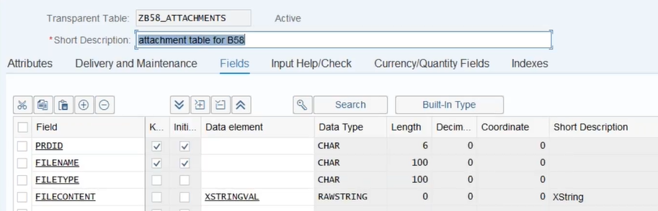

Create the Entity in ODATA Model using above table. For attachment related entity we need to **check thing and media check box.**

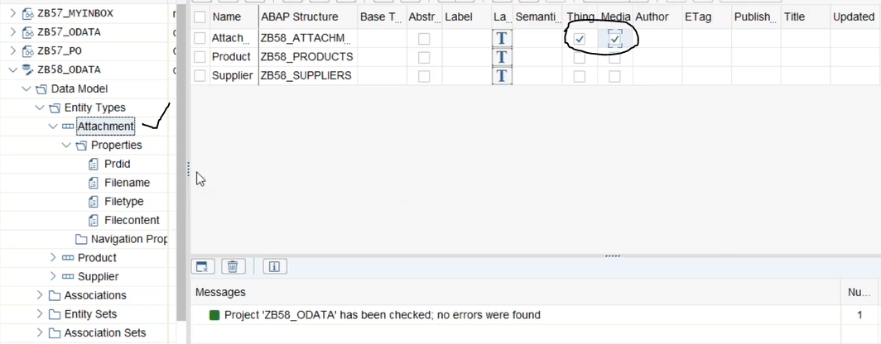

In back-end 🡪 for file upload **create_Stream** method will execute.

For file Download **get_Stream** method will execute.

Under addition of suppliers table, we need to add file uploader to attach the files. In XML view below logic must write for file Uploader.

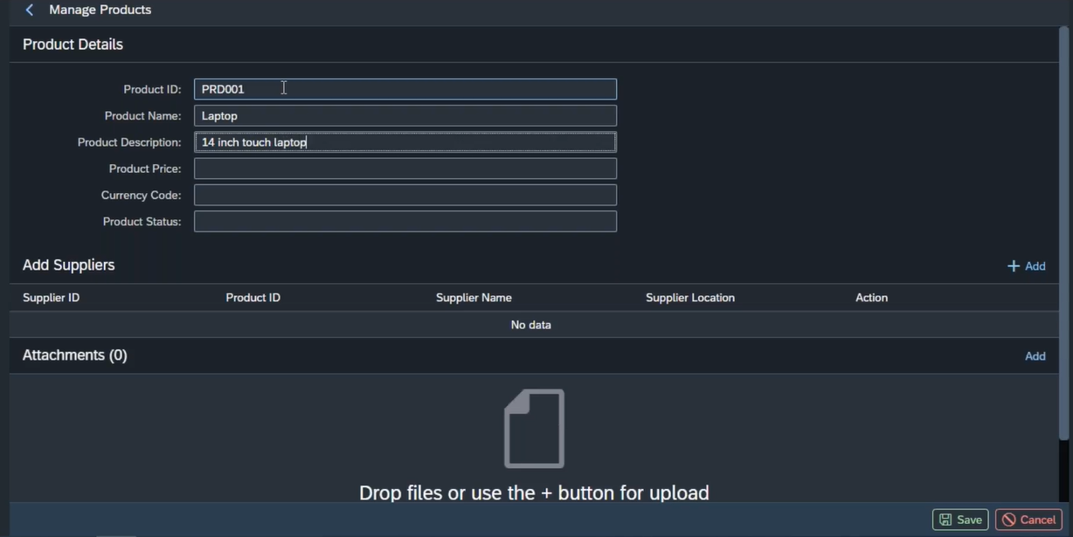

For above attachment we need to write below log in XML View.



The movement we select the file to attach, the function **change** will trigger. We need to add one library **“sap/m/UploadCollectionParameter”** with namespace UploadCollectionParameter in controller. Why did we use this library for file upload activity we need to send one parameter **x-csrf token** forcefully? X-csrf token is security token transfer between front-end and back-end. Actually, this x-csrf token go to and forth between server and front-end for every request, not only for file handling, for each and every database operation(CRUD operations) but for CRUD operation we are not sending this security token because the ODATA model object automatically take care of sending this x-csrf token from browser to server.

**X-csrf-token:** CSRF stands for cross side request forgery. This XCSRF we no need to handle for CRUDQ operations, ODATA service will take care of it, for file handling we need to handle this. This xcsrf token code has to be write in **change event**.

In **beforeUploadStarts** event we need to send the file contents, in any file we have only four fields **ProductID(Key Field) ,filename, filetype, fileContnet** here filetype and file Name will take care by **fileuploader** based on the file which we have attached. Remaining two key field and file content we have to send back through **SLUG parameter** by separator (comma or /).The logic in controller is as below.

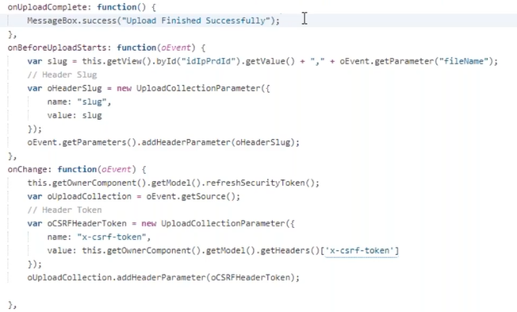

In backend we need to collect the file content in **create_Stream** method of ODATA service. Whatever the fields take care by file uploader in front end those fields we can collect by **IS_MEDIA_RESOURCE** parameter**.** So that we can get all four fields in this method. Two from IS_MEDIA_RESOURCE and remaining two from **IV_SLUG**.

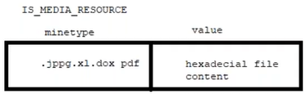

The logic in create_Stream method of ODATA service is as below.

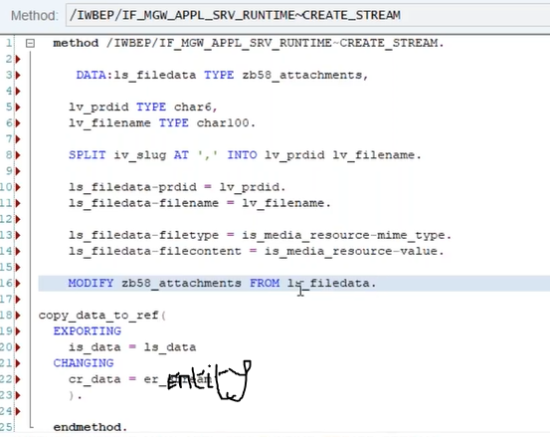

**Download Attachment:**

To download the file, the method which is called in back-end is **GET_STREAM.**

The ODATA service URI which will call this get_Stream method. If we want to download the file from front-end, exactly we need to call below URL



The logic we must write in back-end **GET_STREAM** method of ODATA service is as below.

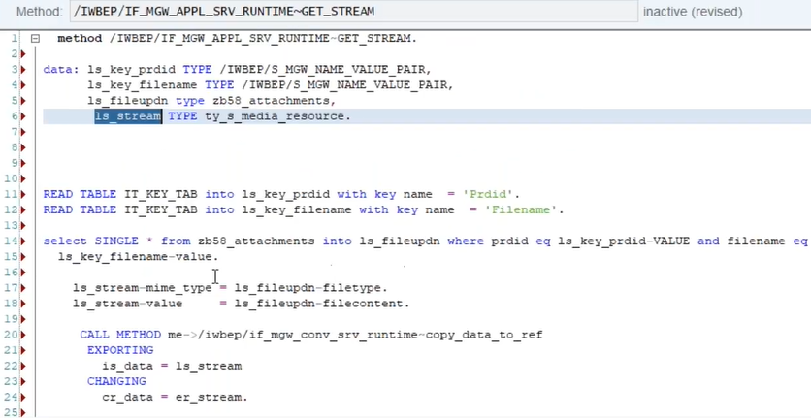

Whenever user click on any product on products table, it will navigate to next view here we will find the more information, suppliers’ data IconTabBar beside these we need to create one more IconTabBar which is attachments here we can see that product images.

In attachments tab we need to display the images related to selected product which is possible using **association** between productSet and attachmentSet.

So in ODATA service (SEGW) we need to create Association between those two EntitySet.

The URL from browser is like below.



When we call the navigation property it will execute the **ATTACHMENTSET_GET_ENTITYSET** method and the method logic is as below.

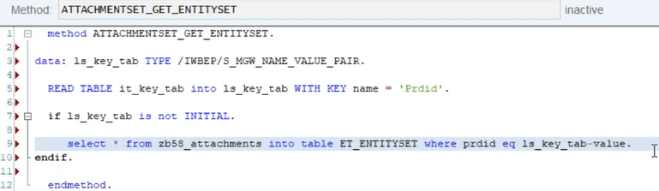

Now we need to design the attachments IconTabBar in view level, here we can display all images related to selected product in table format, the screen and logic is as below.

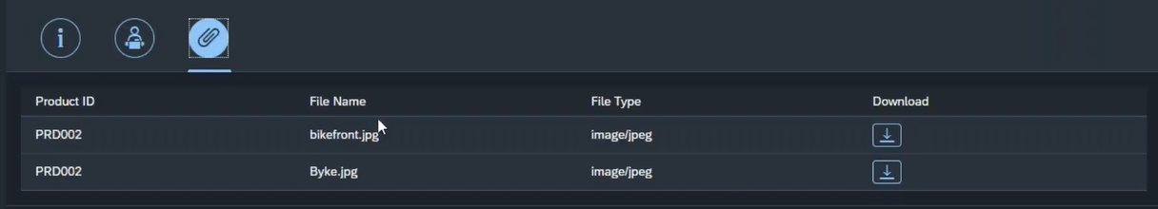

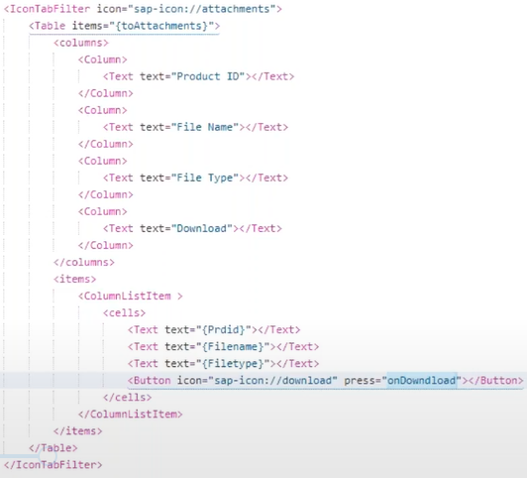

When user click on download button on any row of the image attachment, that image will get downloaded.

We need to construct the URL as below to download the attachment. This is the only one URL to download the attachment without any additional code.



The above URL construction when user click on download button of image below, then the function will execute that logic as below.

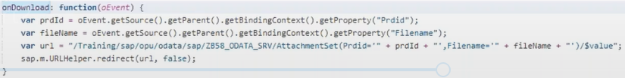

Add one more IconTabBar which is used to display (not for download) the multiple images in **Carosel** UI element, which is a container for images and its having pages each page holds one image.

To design the photo display IconTabBar in XML view write the logic as below.

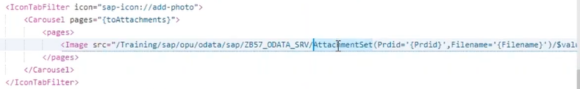

**Excercise6.15:-** Extension to the above exercise whatever the files he saved, when user click on header line items it will display information of header and item details in next view, beside of supplier’s fragment add two more fragments one for display files information with download button in table. In another fragment display files images.

1. **Deployment, Tiles creation, Export to XL,PDF:32-**

**Export Table Data into Excel and PDF:** This is the real time scenario.

**Excel:**

Here we need to create the one button on table headerToolBar in XML View, the code is as below.

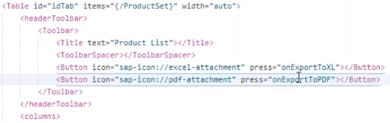

By pressing the above button we need to download the table data into Excel file, by pressing the button onExportToXL function code will execute and that code is as below.

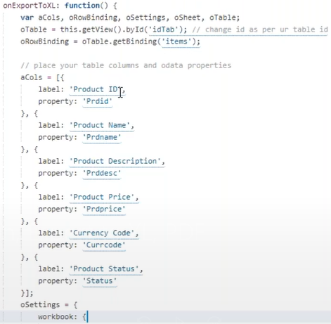

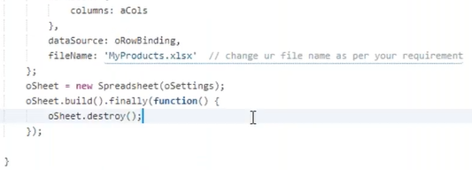

SAP has given one library called spreadsheet to download into Excel.



**PDF:** SAP has not given any library to download the table into PDF, we need to use third party library.

**Step1:** There are three libraries are required to export table data into PDF. Those we need to include in libs folder of the project.

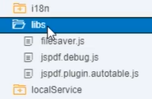

**Step2:** Adding these libraries into project folder those files will not be loaded, we need to add these files in manifest.json file of resources section.

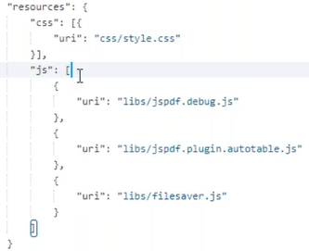

**Step3:** Whenever user click on pdf button then that function code will trigger, which is as below.

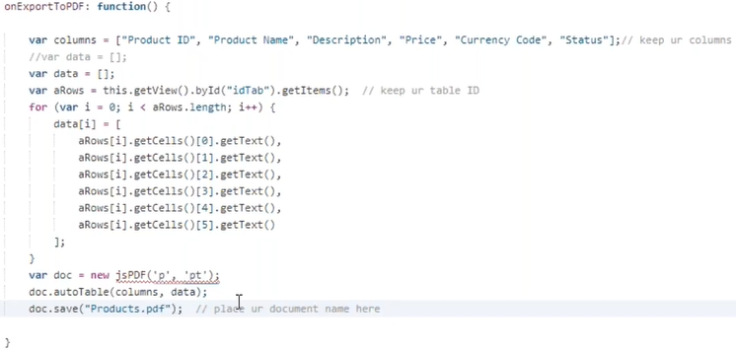

**Application Deployment to Server:**

Right click on project 🡪 Deploy 🡪 Deploy to SAPUI5 ABAP repository 🡪 Select our system where we want to deploy the application 🡪 select deploy a new application 🡪 press on **Next** 🡪 give the **name** start with **Z** and this should not same with our application name and give **description** and give the **Package** 🡪 click on Next 🡪 finish.

After all these steps we will get message. Once the deployment is completed then we can access the SAPUI5 application by below URL (All SAPUI5 applications are present in **sap/bc/ui5_ui5/sap)**.



This is the standard URL to access any UI5 Application.

To access these applications by user we need to keep all those applications in **FIORI LAUNCHPAD**, below are the steps to configure the applications in Launchpad.

**Step1:** Create Semantic Object **–** which is unique identification of **tiles**. Every tile should have different **URL pattern**, that URL pattern is called semantic Object.

**/ui2/semobj** Tcode for create semantic object. Create it as below and save it in TR.



**Step2:** Goto **FIOR Launchpad designer** and this is called as **ADMIN page**.

Normally this part is design by BASIS team or security peoples. The designer URL is as below.



First Create **Catalog** – which is the container for tile. Create a static tile as below under Catalog.

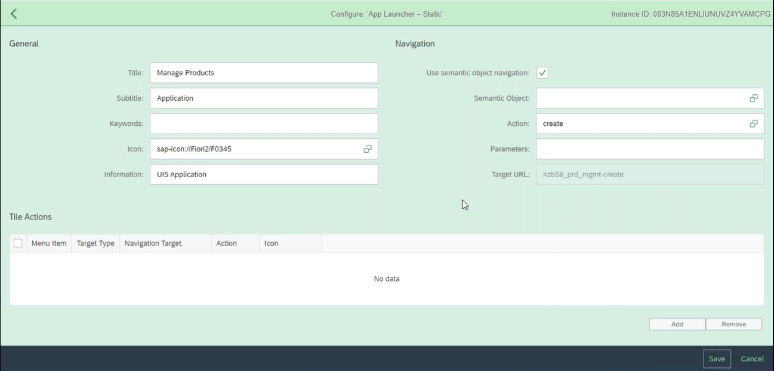

Here we need to fill the **Target Mapping** under Catalog as below.

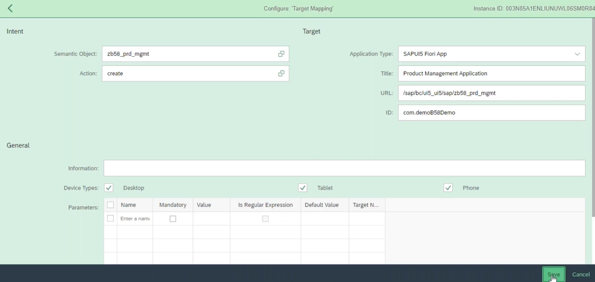

The create **Group** – Create a Group add above tile into this group.

**Step3:** to assign this tile to end-user (not for all users, whoever want to access this app).

This can be done using **FIORI Role,** the creation of the FIORI role in **PFCG Tcode.**

After creation of Role, we need to add the above Tile and Group.

In **MENU** Tab🡪 select SAP FIORI Tile Catalog 🡪give Catalog name 🡪 press continue.

In MENU Tab 🡪 Select SAP FIORI Tile Group 🡪give GROUP name 🡪press continue.

Now we need to add user’s ID in user tab those who want to access this application.

1. **Batch Operation:33**

It is a collection of individual requests, instead of sending individual request’s multiple times. Collecting them as a batch and sending it as a request.

Why this batch request is required:

* 1. To improve the performance of the application. (Any CRUD operation executes bulk size means want to create multiple products, want to delete multiple products at a time).
  2. Instead of sending multiple requests to back-end system, keep all the requests in batch container then send one request to backend, the ODATA framework will pull those individual requests and send them to operation.

How the Batch operations can handle from SAPUI5.Normally in Realtime we will upload the data from Excel and display them in table (optional) and save them in back-end using batch operation.

**Exercise: excel file uploader** and display them in table.

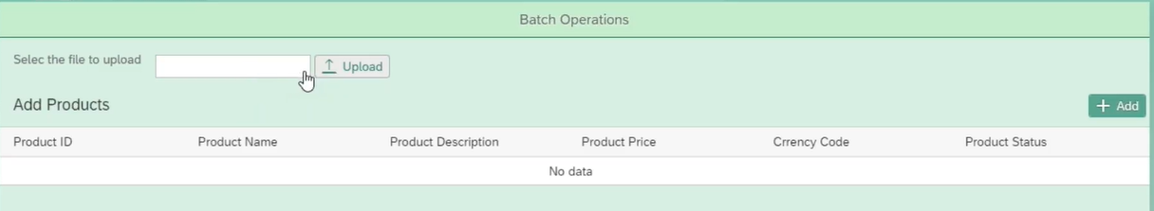

File type to **CSV** or **XLSX,** even if we have not mentioned file type default it will take XLSX.

**Note:** The excel file column names should match with the ODATA fields.

Design the above screen shot in XML View as below.

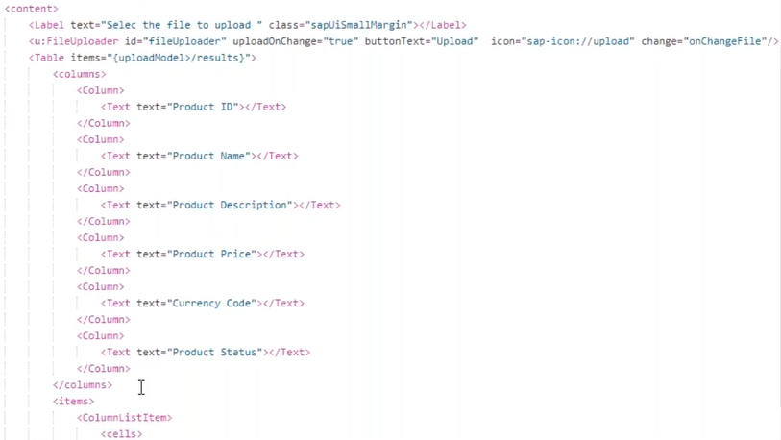

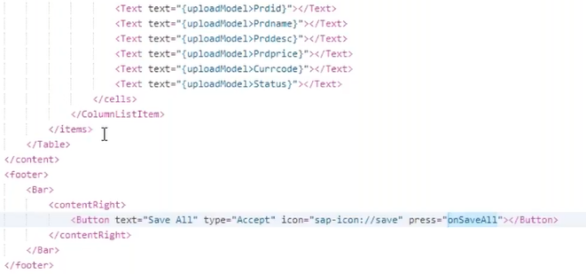

We need to keep below third-party java script library files in util folder under our webapp folder.

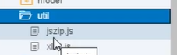

We need to load these files in manifest.json file.

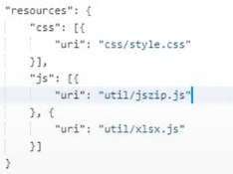

When user click on Upload button, we need to select CSV/XLSX file, then that data will display in below table. The logic is as below.

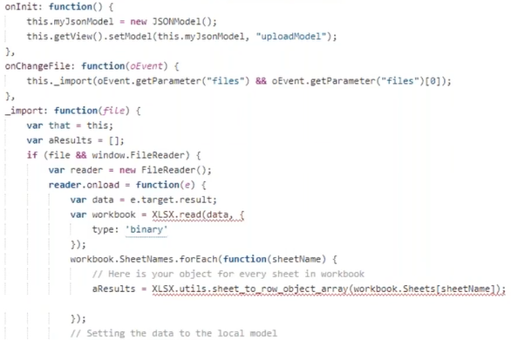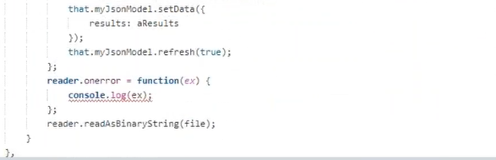

After confirming the records, user has to save the table data into back-end using batch operation. Then user has to click on save button, the logic is as below.

Till the loop get executed all the records go and sit in batch by groupID.

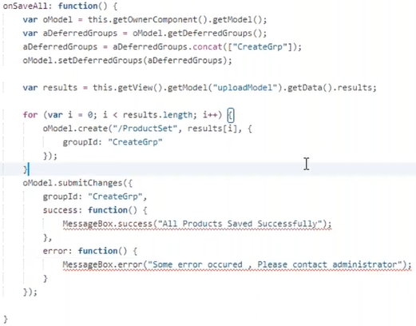

In back end we need to redefine two functions, no need to write any logic inside.

**CHANGESET_BEGIN** and **CHANGESET_END**.

1. **Charts:34**

Charts in SAPUI5 are developed by three major Libraries these are sub libraries of parent library.

The parent library is **viz,** this viz library having **vizFrame** which is having **height** and **width** properties within these height and width it will create a space (frame) to display the chart.

This vizFrame having another property **type. (**What type of chart we want to display).

Under the **viz** library we will use another library called **data** which is having a property of **dataset** this property holds the **EntitySet (** Which we want to display the data as a chart**).**

**dimensionDefinition** is for display on X-Axis

**measure Definition** is for display on Y-Axis.

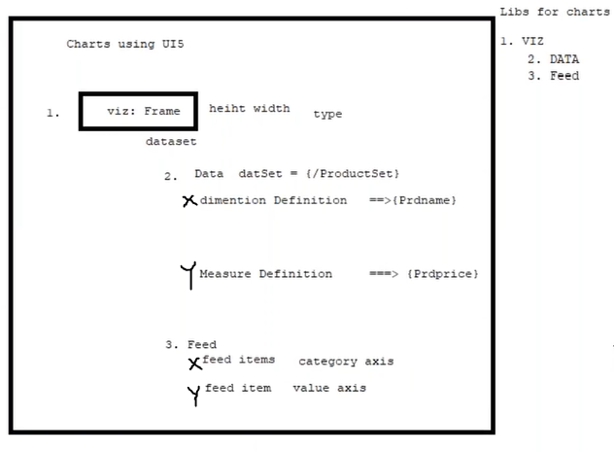

We can design the chart using below login in XML View.

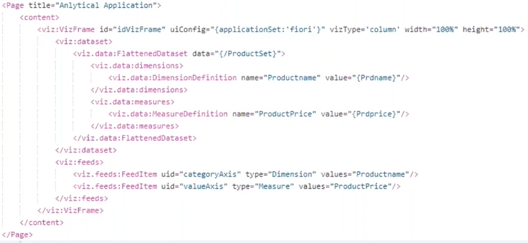

The above logic will work for bar chart, column chart and line chart. Because the pie chart doesn’t have X-Axis and Y-Axis. So, we need to change the **FeedItem** because the pie chart is not having Axis’s

For pie chart we must write the logic as below in **feeds.**



Using below code in Init method of view controller we can change the title of the chart, X-Axis name, Y-Axis Name and Value of chart (bar, column... etc.) occupied.

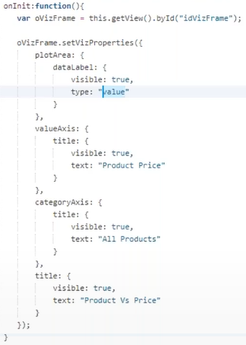

1. **Popover Scenario in Chart and Internationalization:35**

As many as products are increasing the chart columns on X-Axis are increasing and those are very thin and there is no gap much between them. In this situation a popover concept will come.

In the view we have to define on above the vizFrame lane as below.



After including the above code in XML view, then we include below code in view controller below the oVizframe declaration.

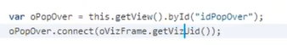

**Exercise:**  give the drop down to change the chart type dynamically. So, we were adding logic in XML as below.

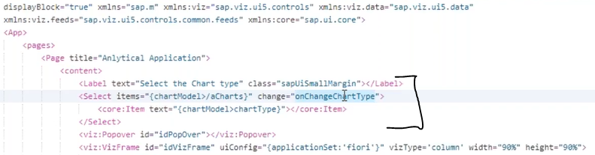

When user select any value from Select box based on that value the chart type will change that logic is as below in controller.

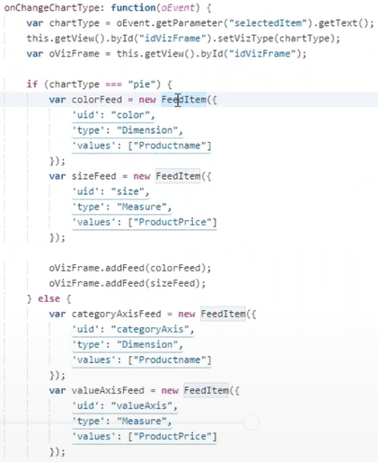

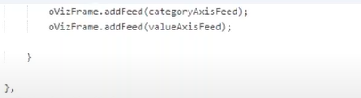

To add the feed dynamically, we must add library in scaffolding template of controller as below.

**Internationalization:** Supporting our application in multiple languages is called internationalization.

From FIORI Launchpad we have a login pad here we should select our language to get the launchpad in that selected language.

To test the internationalization, we must deploy the application in launchpad.

Whenever we want to implement the internationalization for our application, first hardcoded texts replace with i18n file text.

In, how many languages we need to print the application that many files we need to maintain in i18n folder with suffix of **‘_<Language Code>’**.

In those files we must maintain the text with respective languages.

1. **UploadSet**

UploadSet is used to upload multiple files at a time.

The view design using UploadSet is as below.

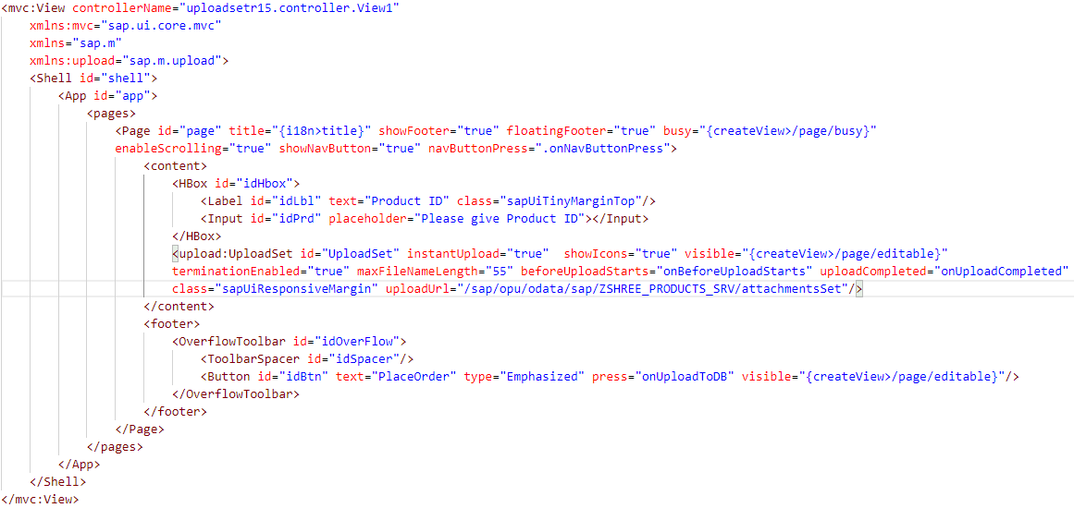

The controller Code is as below.

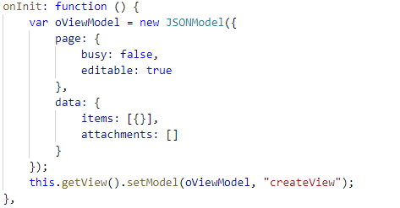

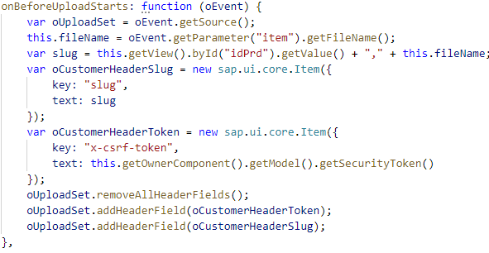

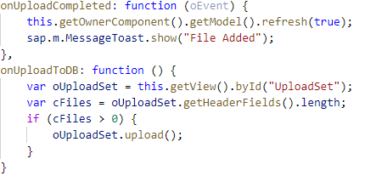

**Reference Link**- <https://abappolice.com/2021/09/save-attachment-to-gos-from-sapui5-fiori/>

**FIORI**

1. **Introduction**

Category of FIORI is as below.

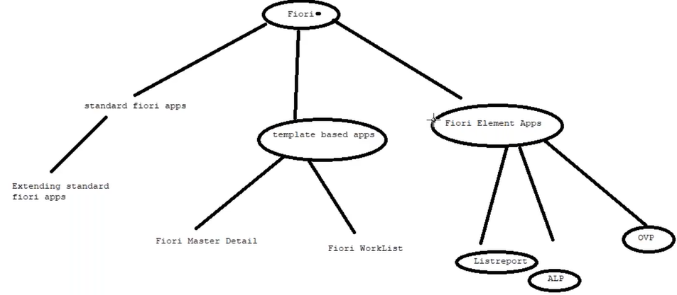

**Template based Applications:**

**Master-Detail** and **WorkList** applications are template-based applications 90% of the code automatically generated. Under these applications instead of Page tag we will use **Semantic page**.

Difference between Page and Semantic Page-

While creating the Master-Detail application using master-detail template we can select the details.

These Master-Detail and WorkList applications are called as FIORI like application.

**Master-Detail Application:**

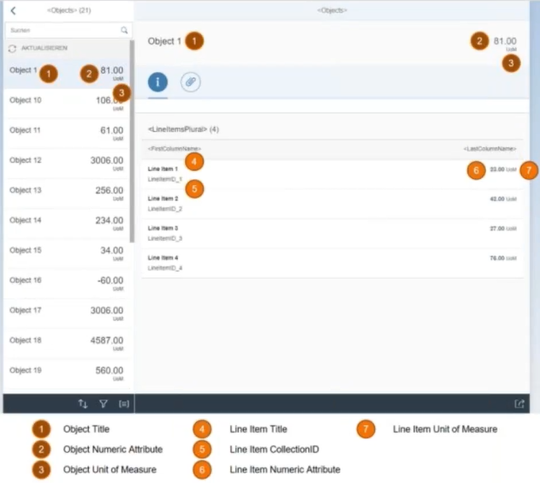

After code generated for master-Detail Application looks like below, if we want to change anything we must follow below steps.

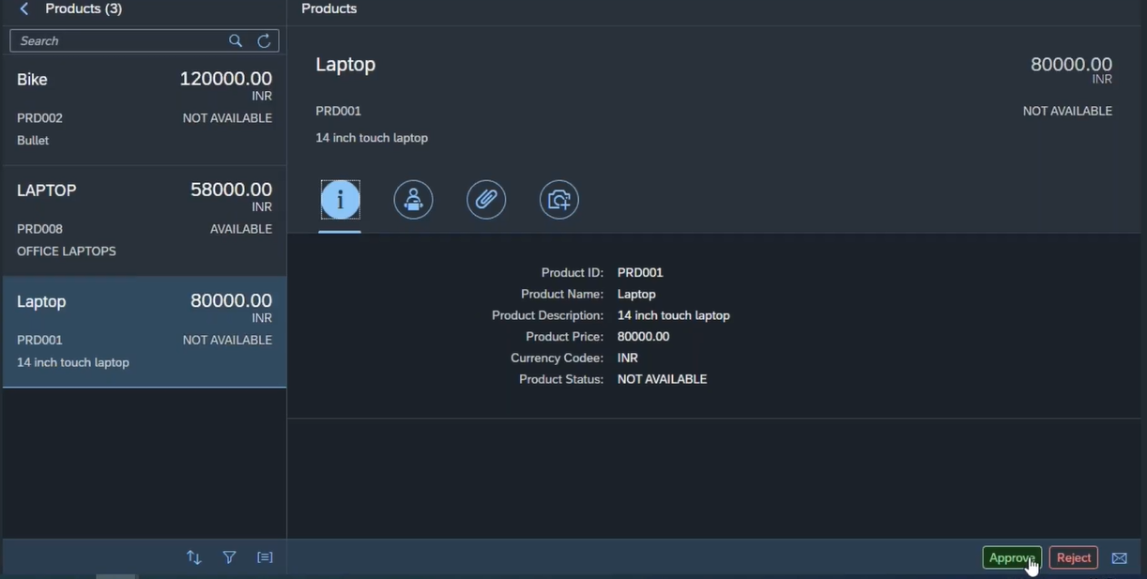

1. First change the text in i18n.
2. Edit Master page as we required.

If want to do any changes in Master page, find the list UI element in XML View and add the attributes aggregation, FirstStatus and etc …

1. Edit detail page as we required.

Same as above point, we can change the detail page in ObjectHeader or inside content of icon tab filters.

1. Create any action on detail page footer.

**Note:** Normally this Master-Detail application is used for **Approve/ Reject** scenario only.

To add approve and reject buttons in view the logic is as below,this logic we can write **abefore** the end tag of **</semantic:DetailPage>.**

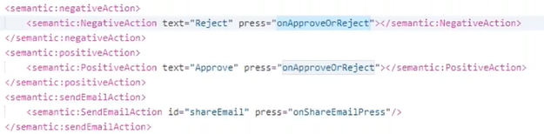

If user click on Approve button the product status should update as Approve, whereas for Reject, status should update as Reject for this am using **EXECUTE_ACTION** opertion in Back-end. The URL is as below.



The **EXECUTE_ACTION** will execute any type of opertaion.To Execute the EXECUTE_ACTION method we should create the **FUNCTION_IMPORT** in back-end ODATA Service first.From front end if we call function import the EXECUTE_ACTION method will trigger.

When user click on any one of the above button below functin logic will trigger which inturn execute the EXECUTE_ACTION method as below.

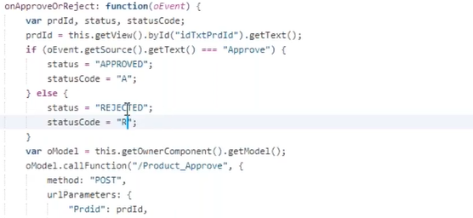 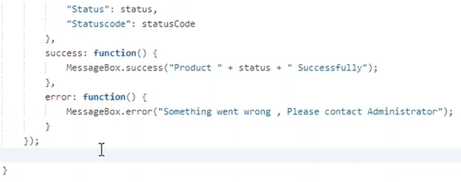

In Back-end we straight away execute the EXECUTE_ACTION method. In this method having **IT_PARAMETER** parameter, which is having two variables **name** and **value** and the logic is as below.

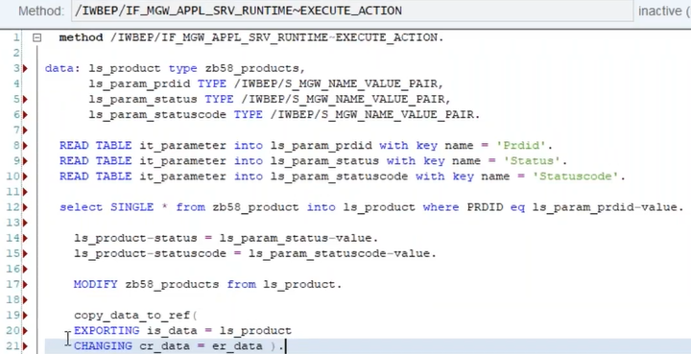

**Work List:** This Worklist and Master-detail Applications are used for decision making purpose.

And the steps are same as Master-detail Application.

1. **List Report Application with CDS and Annotation: 38**

This is coming into FIORI Element based applications, under this there are three which are **List Report, ALP, and OVP**. But in Realtime we will use List Report mostly.

The speciality of these applications is **without any code** the applications will generate, even we don’t have any scope to write the logic for UI element design. Then how we will get UI elements display is using **CDS views with Annotation**.

Normally the List Report application is using for displaying large volume of data, then user will get the data based on filter or query.

**CDS with Annotation:** Explanation using Eclipse Tool.

**Note:** SAP recommends the **Eclipse Insta** tool to develop the SAP objects.

First we should create ABAP project 🡪Left side right click 🡪new 🡪ABAP project 🡪 system selection 🡪 give client, username and password. The ABAP project gets created.

Expand the project as below, to create the CDS right click on core data service 🡪 Data definition 🡪 name of the CDS, Description and package 🡪 next 🡪 finish. Then empty template has been created.

**Note:** The CDS which will be exposed like a ODATA service, using an annotation **@odata.publish :true**.

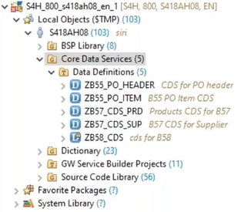

Create a CDS for Products and suppliers, before creating the Association first activate CDS, then only we can create the association between products and suppliers.



After creation of Navigation property in CDS then we should activate the CDS, before activating it we can expose this CDS like ODATA service then we can activate. Below statement will do like ODATA service.



Once this CDS gets activated, the ODATA service URL will generate, the CDS view is as below before applying annotations.

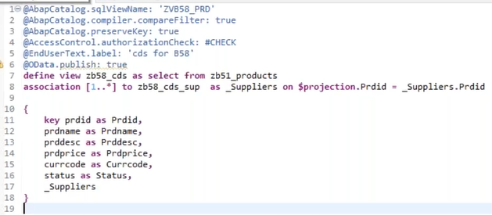

Then we need to add the ODATA service with gateway system. We should go to **/IWFND/MAINT_SERVICE** t-code to add this ODATA service into Gateway system.

**Note:**

* EntitySet we can find in **Entity container** of ODATA metadata.
* In CDS ODATA service we need to develop any method of DPC_EXT class, automatically we will get the data.
* Using CDS we can develop the front-end application for Read operation (Display purpose), but we cannot do UPDATE, CREATE and Delete purpose.

After all these steps in CDS, we need to create the **Annotation** step by step, this annotation will generate front-end interface. To create **column in table** we should follow below thing in annotation above the fields.



By default, we will get table column names as OData field names, if want to change our own label as column name then we should go with below annotation on above fields of CDS. In 2nd page header information by default, we won’t get the labels, with below same annotation we will get those labels also.



For **filter options** we should go with below format of annotation on above the fields in CDS.



When user click on any row of list-report this will navigate to next view there we can display, header information and that item information, for that we should write the below annotation on above the fields of CDS to display header information.



To get the item details for selected header details, we should go with below annotation to display the item details in table.in items CDS view.



To display the number of rows(records) are present in Header table we should go with below annotation inside the CDS (not on above the fields).



To display the selected header item number in second view as a title, can be done using below annotation inside the CDS (not on above the fields), this is extension to above annotation.



After all annotations applied in CDS view, which is looks like below.

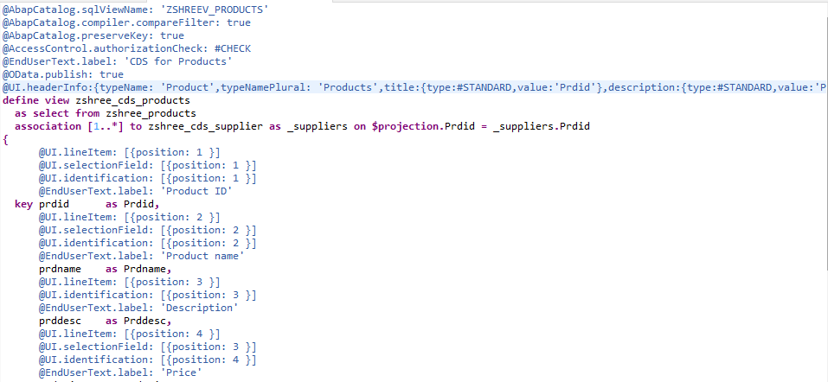

While creating the List Report application in front-end (SAP WEBIDE), ODATA service connection we should go with **service Catalog**, not service URL. The application which created using CDS ODATA service, that application does not contain any views, controller, and the list-report front-end looks like as below.

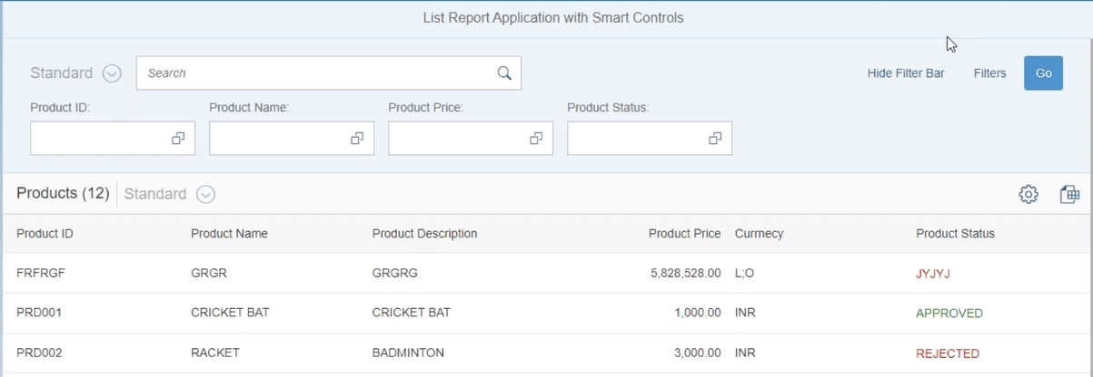

**Note:**  We cannot add drop down, check box and all in list report with annotations on top of CDS. Whatever the UI elements are generated with annotation on top of CDS Views are called as **smart control** UI element.

1. **List Report Application with Smart Controls: 39**

Without annotations the smart controls will not work, which means if the back-end system is ECC we cannot use smart controls, only if we have **back-end system is HANA** then only we can use smart controls in front-end applications.

All these smart controls are internally normal controls only.

**Exercise:** Create the List-Report using smart control and use CDS view ODATA service.

**Note:** After creation of project using SAPUI5 template in WEBIDE, we must add ODATA service which is created using CDS view annotation.

In **manifest.json** file we should add annotation part in **sap.app** section as below.

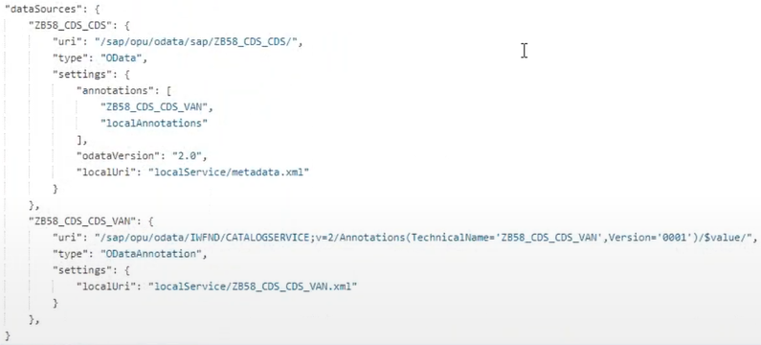

Smart controls are available in separate library is **sap.ui.comp.**

**SmartFilterBar** is a container for **smartFilters**, there is property in SmartFilterBar is **persistencyKey** is used for getting the filter values from filter area to the smart table to get the filtered records.

The smart filter area using smart control UI elements design in XML view as below.

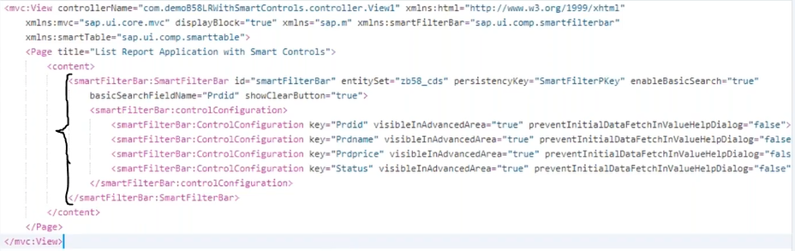

**Note:** To reduce the normal UI elements thickness, we can write one line of code in particular controller **onInit** function as below. But this will not work for smart control UI element, any how the size of UI elements become compact when it deploys into Launchpad.

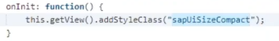

Create the smart table under the smart filter bar in XML view the logic is as below.



When user click on any one record of the smartTable then it will navigate to next view and display the Header information and their item details as well in **ObjectPageLayout.**

By default, we will not get navigatable property for smartTable and there is no property of **mode** as normal table(we can get the mode property from normal table because of smart control UI elements are part of Normal UI elements only). To get the smartTable records are navigatable then we need to write the below logic in controller onInit function.

For smartTable we don’t have an event called **Press**, **selectionChange,** and we know the fact that the smartTable is derived from normal table. We need to send the ProductID to second view.

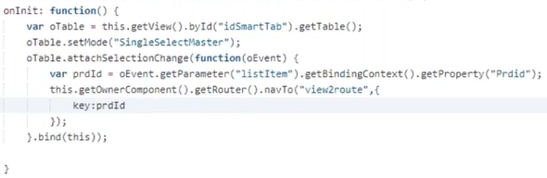

We will get the ProductID in view2 controller and apply bindElement to view as below.

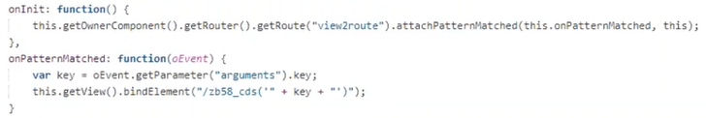

The second view logic as below. SmartForm is derived from simpleForm, Group is nothing but core: Title smartField is derived from Input field.

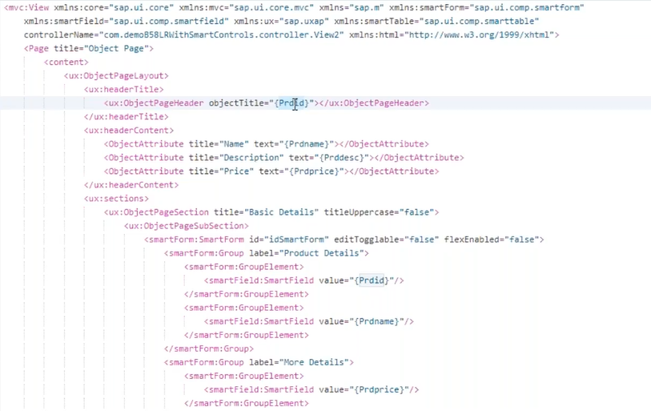

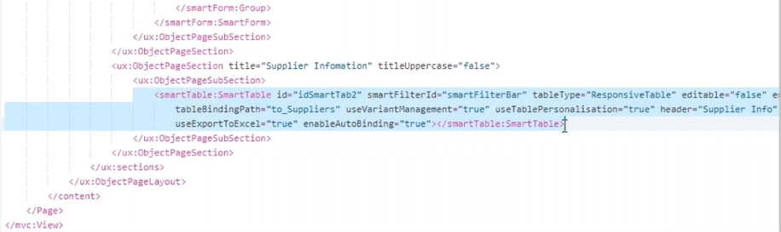

We can apply formatter for status column in smartTable to get ‘AVAILABLE’ in green color and ‘NOT-AVAILABLE’ in red color, in controller we should maintain the formatter. In view which column we customize that column we should maintain that in SmartTable starting tag and end tag. The logic to customize the any column is as below.

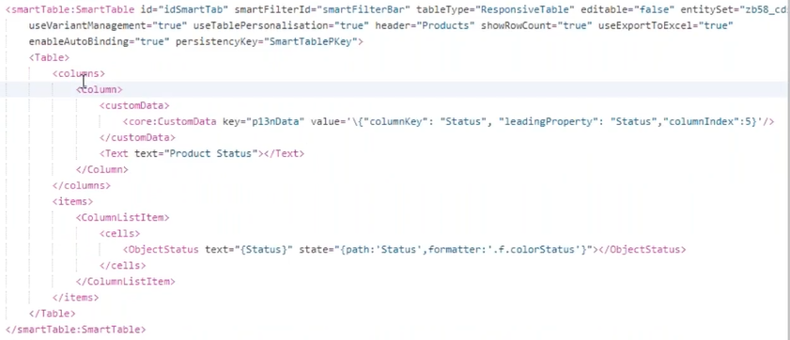

1. **List Report and ALP in BAS:40-**

ALP and OVP is not available in Local WEB IDE, if want to develop these applications we go with licensed WEB IDE or SAP BAS.

**List Report:**

If we create a LIST REPORT in BAS by default, we will not get any item records in view2 for selected header record from view1, so we need to add two more annotations which are called as **facets.**

A facet is nothing but an Object page layout section.one facet means one section.

In products CDS view we need to add two facets one is for general information and another one is for suppliers’ information.

For logic for above facet in products CDS is as below.

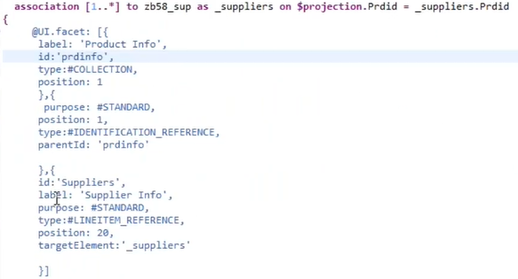

**ALP:**

The difference between List Report and Analytical List page is, in Analytical List page we can get a **chart** between search fields and a table in first view,second page of both are 100% same.

For decimal field we need to add below annottaion to get the summation.



we need to add **chart annottation** on above define section as below, add one more **annotation presentationVariant** to display our chart.

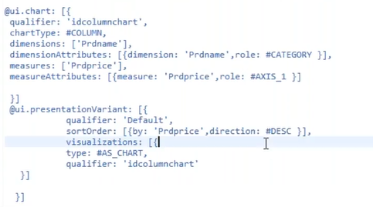

In ALP first page by default, we will not get the middle Chart, and on top right corner there are two icons one is compact filter and visual filter. The **compact filer** is working fine by default, but the **visual filter** is not working which need annotation.

To getting display the middle chart, we should **qualifier ID** of **presentationVariant** in fron-end application under manfest.json file give this ID in analyticalListPage configuration.(Whatever the **ID of qualifier** in presenattaionVariant annotaion,we should maintain the same ID in manifest.json file as below.

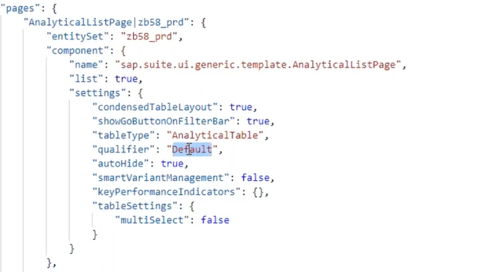

The second difference is between ALP and List Report is **Visual Filter,** which means whatever the compact filter fields will do to filter the records **,** same thing will do visual filter using chart.Bydefault this visual filter is not working, for each visual filter needs chart annotation,presentatiovariant annotations.The annotation we need to maintain on the above of definition part as below.

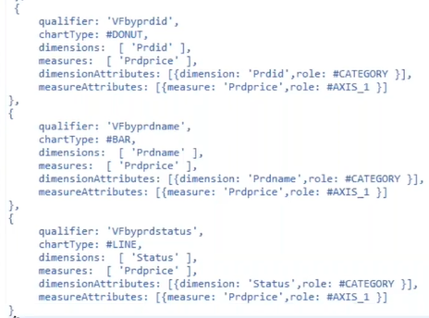

After apllying the aove lines of code under @UI.chart annotation, we need to maintain the few lines of code as above under @UI.presentationVaraiant to display the charts.

In compact filetr wehen we apply the filter automaticlly those related records will display in below table, because in @UI.lineIitem and @UI-selectionField annotation the fields are same as table fields.

But in visualfilter we will not get the filetered values, need to conver the visualfilters as selctionfield, to convert them as selectionfield there is no any UI annotation. So we should go and add it infront-end as below.

Goto our project right click 🡪 SAP FIORI Tools- Open guided Development 🡪 in search guide write visual filters and apply 🡪 select add a **new visual filter** under Analytical List Page 🡪 directly select **STEP3** because step1, step2 are completed in CDS view.

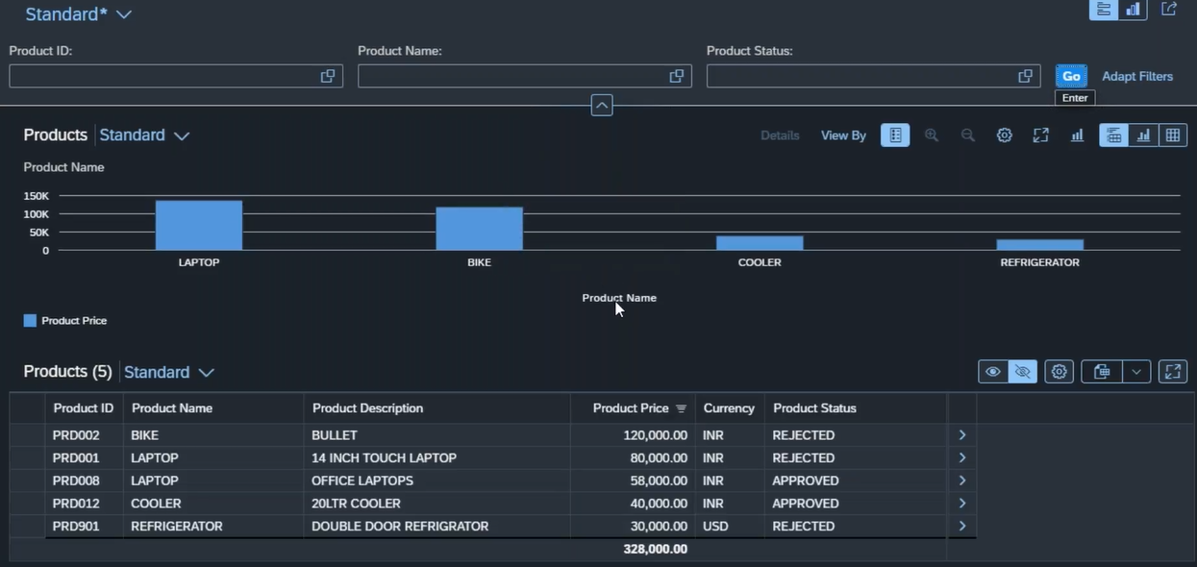

In visual filter only pie, bar and line chart are possible. The each and every chart need PresentationVariant.

1. **Overview Page:41**

For overview page we no need to create separate CDS, same CDS will work with extra two annotations which are

* + - Criticality
    - Intentbased annotation.

An Overview page is a collection of cards, the different type of cards are

* List card
* List with bar chart
* Link List
* Table
* Stack card
* Analytical card

Internally these cards nothing but normal SAP UI elements only. Out of 6 cards we use only 3 cards to fulfil the business requirement.

To create the **List cards** on our OVP project right click on Project🡪select SAP FIORI tools – open guided development 🡪select add a list card on OVP 🡪Expand it and click on **start Guide 🡪** here it will ask about card configuration details then it will generate the code snippet then click on **insert snippet.** Then click on Exit guide.

Whatever the configuration we did for cards that will be available in manifest.json file. After this card configuration we will get the card in output.

To get the color for price we need to add a annotation **criticality** in CDS.

**Note:**

1. From one application to another application navigation concept is called as **cross-app navigation**.
2. The combination of semantic object and action called as **intent**. The semantic object and action combination is unique identification for title.

To create the **List with bar chart,** follow the above point to create the List card. In manifest.json file we should add one point bottom of the list with bar chart configuration as below.



**Link list card** is one to use navigate to other application, to create this card follow the same step and choose the LINK LIST CARD and give configuration details.

1. **Extending Standard FIORI App and ODATA Extension:42/43**

If some customers need something extra in standard FIORI App, then Extending the SAP FIORI App will come into picture.

Bringing the **standard FIORI application** into launchpad is not developer activity its BASIS/SECURITY person’s activity. What those peoples will do that we will see here.

**Step1:** First goto fioriappslibrary the website is as below.



Which is a site where all the FIORI apps given by SAP are available.

Select SAP FIOR apps for SAP S4/HANA🡪 All apps 🡪 here we can search for required app **Ex: My inbox.** Then on right hand side we can find the **PRODUCT FEATURES, IMPLEMENTATION INFORMATION**. In Product information the app description and sample images of this application.

In Implementation information we can get the information to enable this application under installation we should check all the installations are available or not in our system. The **front-end** **and back-end components** must be ready in our system (normally we send this picture to basis peoples to check these components are exist are not) to configure the application.

In configuration exact configuration details are available to create the tiles in Launchpad.

🡪**For custom Application** we should follow below points **2-4** to deploy it in Launchpad.

**Step2:** Create a Semantic Object.

Which is a unique identification for FIORI tile.

**Step3:** FLP Admin, Here creates a Catalog, Group and add tile to the group.

**Step4:** Create a Role and Assign the Catalog and Group. Assign this Role to User.

🡪**For Standard Applications** we need not to create the semantic Object. Because semantic Object and Action already given. Except **2nd** Step we should follow remaing steps.

**Standard FIORI Application Configuration:**

1. Step1- from **FIORI Apps library**, get the standard Catalog (Business Catalog).
2. Catalog Creation:

Step3- Login to ADMIN Launchpad and create one custom Catalog, open the standard **Catalog** (which we got from FIORI apps library), and copy the **standard tile** to custom Catalog by drag and drop in create reference🡪 give our custom Catalog name.

We should copy the standard **TargetMapping** to custom Catalog by select TargetMapping 🡪 press on Create Reference.

The **dotted line** around the tile indicates that, this tile is referenced tile from standard tile. We can remove this dotted line by changing anything in the tile.

In TargetMapping also, we can find the ‘**this is reference TargetMapping**’, we can remove it by any change in TargetMapping.

Group Creation:

Create one Group in Launchpad and add above tile into this Group.

1. Step4- Goto PFCG T-Code create one Role, inside the role goto **Menu tab** and assign the **FIORI Catalog** **and Group**.

Then Goto **USER tab** assign users to whom the application can access authority.

**Note:** Normally the order of App’s in FIORI Launchpad is based on **index** we have provide in role under Menu Tab🡪 Menu Options🡪sort Index.

**Extension of the Standard FIORI Application:**

For Extension of Standard FIORI app documentation goto fioriappslibrary 🡪Implementation Information 🡪Extensibility.

In Extensibility section clearly mention what are the possible extensions available within the Application.

What are the Extensions are present?

Front-end FIORI Application

Back-end ODATA Project

**Exercise:** Extend the My Inbox Application, add one more filed in master list.

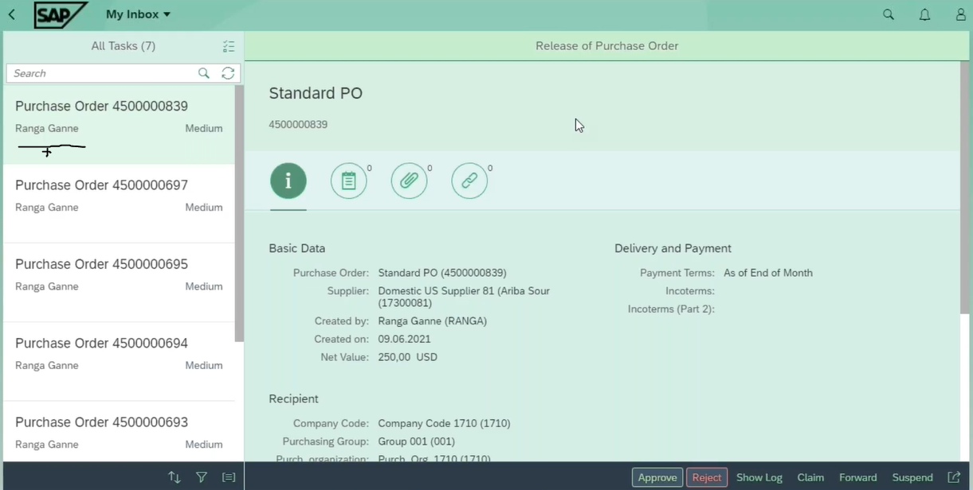

**Extend the Back end ODATA Service:**

**Step1:** first extend the standard ODATA project.

To extend the standard ODATA project **create one custom ODATA project**, this custom ODATA must **refer the standard ODATA**. Refer the standard ODATA like this right click on Data model 🡪Redefine 🡪 ODATA service, here we need to give standard ODATA name in technical service name and version 🡪 click on Next, here select all entity’s 🡪click on Finish. **(SEGW)**

Select the ODATA project click on generate run time objects.

**Step2:** Add this ODATA project into NW gate way service.  **(/iwfnd/maint_service).**

**Step3:** To add new values in master list of the standard FIORI app, first we must add these fields into entity. To find which EntitySet is bind with master list, goto browser console under network tab **$batch** we can find the EntitySet under **Request payload** which is as below.

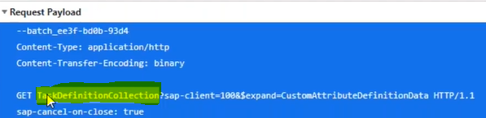

After find the EntitySet we need to confirm either is it right one or not, for that we should open the ODATA metadata and search those EntitySet names under EntityContainer. If we find the EntitySet in EntityContainer beside that we can find the Entity name also, then goto Entity and find the fields which are displaying in application.

We need to add one extra field in that entity🡪 goto **SEGW** open that entity and add one more filed, since we have added a field in entity so generate the runtime objects.(the field which we have added that should be available in database table if not available first we need to add it into DBT).

**Note:** in custom application if the Entity name is for example **products,** then the EntitySet name is **productsSet**, if **abcd** is entity then the EntitySet is **abcdSet**.

In standard applications the Entity is **task** then the EntitySet is **EntitySet_task**, if **Abcd** then **EntitySet_Abcd**.

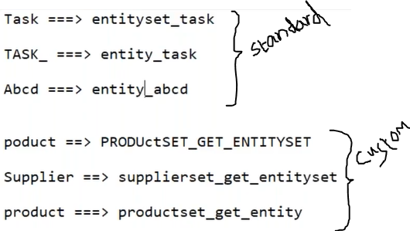

Open DPC_EXT class and redefine the ENTITYSET_TASK, before redefining the method just copy the code which is already present in this method. Then paste this code after redefining the method.

Instead of sending the final table **LT_TASKS** to front-end, define one final internal table in method.

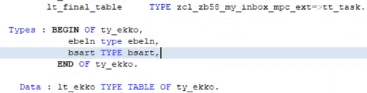

Before calling the **copy_data_to_ref** method, write the below logic.

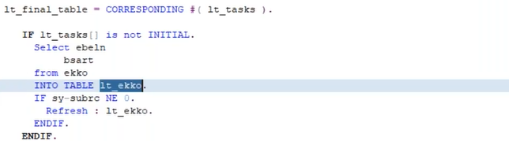

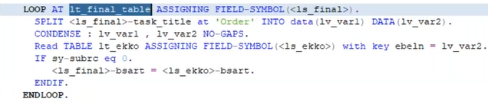

After all these logics we need to send it to Front-end as below.

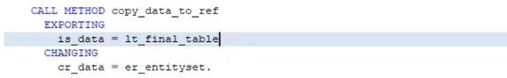

**Front end application Extension:**

**Step1:** open WEBIDE 🡪 Right click on Workspace 🡪 new 🡪 Extension Project 🡪Give Origin Application which is always present in SAPUI5 ABAP Repository(We can get the Application name(Technical Name) from fioriappslibrary 🡪 click on Next 🡪 Finish.

**Note:** The below statement which is saying that extending the application from standard FIORI app present in **Component.js**.

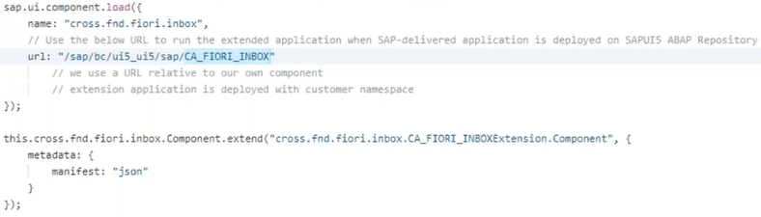

In Front-end Standard FIORI Application can be extend using 6-7 techniques:

1. View Modification. 🡪Only Hide, Unhide UI Element.
2. View Extension. 🡪 Enhancement point or extension point. (It is a point where developer can insert his logic).
3. Controller Extension 🡪 Extension points in controller to insert some logic (js-code).
4. View Replacement 🡪 If Extension points are not satisfied your requirement, then we can go with original view will be replaced with custom view.(Sap not recommended technique)
5. Controller Replacement 🡪 original controller will be replaced with custom controller.(Sap not recommended technique)
6. Replace standard ODATA service with custom service.
7. Extending i18n.

**Step2:** **Replace the ODATA service with custom Service: -** in step1 extension project. Right click on Project 🡪New 🡪Extension🡪 select Replace Service 🡪Next 🡪 here give our Extended ODATA service and click on Next🡪 Finish.

Here our ODATA service will not load, so we need to add **multi origin support** in dataSources uri of manifest.json

**Note:** in standard FIORI app manifest.json file observe the **dataSources uri** whatever the extensions (**;mo/**) are there same thing we need to apply in extension project also.

**Step3:** **View Modification:** -After step1 extension project to apply view modification goto Tools in Menu bar 🡪 extensibility pane (which is a panel where application output load in left hand side and views and controllers are on right hand side)

Here goto **Extensibility mode** from Preview mode, whatever the UI element would you like to hide, right click on it(that selected UI element comes with purple color) and select **Hide control 🡪 press on Refresh.**  Then that UI element will be hide.

If want to remove the extension(make it unhide) then **right-side Outline** right click on same UI element Remove Extension and click on refresh.

**Step4: View Extension:** -Which means there are extension points given by SAP, where we can include our custom logic.

To add more UI elements in master View List using View Extension.

Goto Extensibility Mode, here where want to add extra UI element select that place then it will become purple color, on Right hand side under Outline we can find the **+Wrench** symbol, which means that is an extension point.

Right click on that extension point and select **Extend** 🡪 Open Extension code. Then code will open, here we can write our own code to insert a new UI element. After including the code with property binding, even if we will not get the value in output which means some standard FIORI app’s apply select query to get the few fields to increase the performance, so we need to include our new field into select query in that view controller for that we should go with controller extension.



**Step5: controller Extension:** Select the Project 🡪 tools🡪 extensibility pane 🡪 Extensibility Mode 🡪 find the view controller and expand look for extension point for select query 🡪extend view controller🡪 open extension code. Here we need to send our new field to select query by below code.

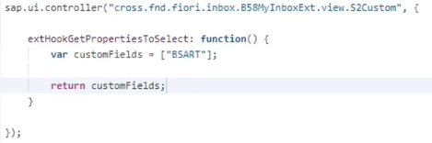

**I18n Extension:** We should not hardcode anything replace the above attribute title with I18n like below.



To change the above title we need to do I18n extension, right click on project🡪New 🡪 Extension 🡪 select I18n resource Text Customization 🡪 Next 🡪 Finish. From Original application it will pull I18n file, open the file and mention DOCTYPE text.

I18n stands for **I**nternationalizatio**n**.

**View Replacement:** Normally SAP will not be recommended because, when the FIORI app gets upgraded those new features are not coming if we go with view replacement.

If we want to add one Button in list UI element of Master view, here we don’t have an extension to add this button, so we should go with view replacement.

Select the Project 🡪 tools🡪 extensibility pane 🡪 Extensibility Mode, on right side goto outline select the view and right click on it 🡪 Replace with a copy of the original view🡪 click on open extension code. The one view with name **<viewname>Custom.view.xml** will be created and add our code to create a Button as below.



If replace the view, whatever the extension we used to include document type those will not come. To get those UI elements we can write in our view itself.

**Controller Replacement:** whenever we do view replacement, then we are forcefully in position to replace the controller.

For above button we need to write the logic when press event is triggered, for that we need to do controller replacement because that button we kept in view which replaced standard view. To replace the controller, we should follow below.

Select the Project 🡪 tools🡪 extensibility pane 🡪 Extensibility Mode, on right side goto outline select the controller. If this controller already extended then we don’t have an option to replace it, so we need to remove extension then replace it, to remove it goto manifest.json file and remove controller extension and come to extensibility pane and do extend the controller with original controller.

Then the extended controller will open, here we need to write our code at the top or bottom in between curly braces without disturbing the existed lines.

1. **Cross App Navigation and Theme Designer:44-**

**Cross App Navigation:** In Realtime when we have multiple applications within the launchpad, navigate from one application to another application is called cross application navigation.

**Exercise:** Cross App navigation with parameter- design below Cross App1 with List, and design Cross App2 with input filed and search button and simpleForm. When user click on any list item in App1 that Product details will display in App2.

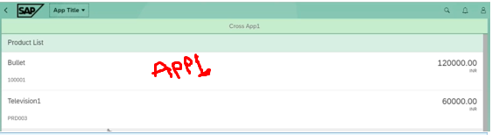

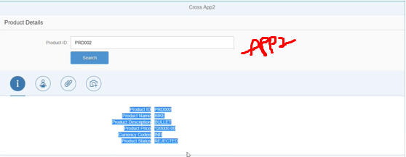

To design the Cross App1 the XML view code as below.

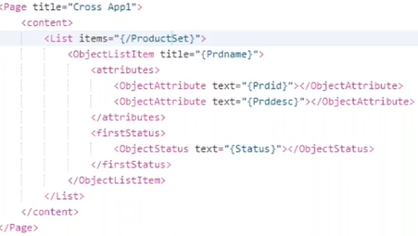

When user click on any product list item from Product lists in Cross App1, then we should read that product id and send it to other application and display product details. Here the controller code is as below.

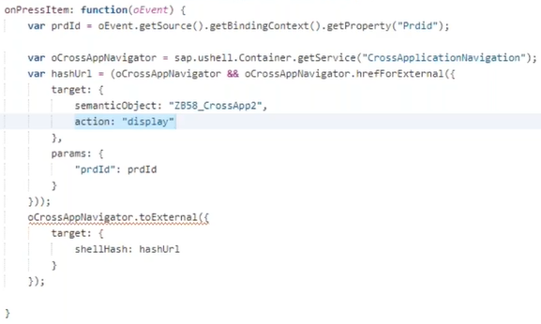

In Cross App2 the XML View code as below.

When we landed up to Cross App2 from Cross App1, we need to get the product ID in App2 controller the code as below.

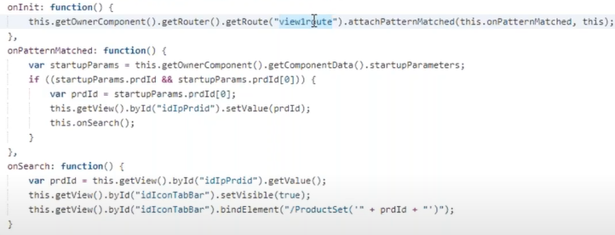

**Note:** Cross Application navigation testing will be done only in launchpad.

After completion of the two cross Application design, we should deploy those two into ABAP Repository.

Then create two Semantic objects for two tiles. Go to FIORI Launchpad designer and crate one new Catalog, add two tiles and apply target mapping for those two tiles.

Create new Group and add above two tiles into this group.

Add these Catalog and Group into new Role and assign users to that role.

**Theme Designer:** we can open this using Tcode or URL, it will open in browser.

Tcode 🡪 **/ui5/theme_designer**

Steps to create a new theme

1. Click on Create a new theme 🡪 choose base theme, click on step2 🡪 theme ID, Title, select Step3 🡪 click on Create Theme. (Support RTL for Arabic country’s this RTL is check; other countries uncheck).

Here RTL stands for Right to Left.

1. Add Target Pages 🡪 give Launchpad URL to Link to Application and give name of Application 🡪 click on Add.

**Interview Questions**

1. **Boot Strap** - Before we can do something in SAPUI5, we need to load and initialize it. This process of loading and initializing is called bootstrapping.

In index.html file **src** attribute of the script tag tells the browser where to find the core Library- it initializes the sapui5 runtime and loads additional resources, such as libraries specified in the **data-sap-ui-libs** attribute.

SAPUI5 supports different theme, we choose default theme **sap_belize** in **data-sap-ui-theme** attribute.

1. **Routing** - In any application as we add more and more features, we need to split the content and put them into separate pages.In SAPUI5 application each web page is having its own different URL, which means part of the URL is different, that part is called as **URL Pattern**, constant URL is called **Domain name.**

Web application on empty pattern load the home page (default Page), based on the Pattern that page will load, this information giving to the application by routing.

**Basically, the router will do** based on pattern it will load the web page, mapping URL pattern to the specific web page is routing.

The Routing totally contains three sections which are.

* **Default value section**, which is executed only once when it’s executed the router body initialized.

We need to initialize the router in component.js. Like **this.getRouter ().initialize ();**

* **Routes section,** tell the target which view to load.
* **Target Section** load your view into view container.

1. **Models** - Model is an object of data.

In SAP UI5 there are **four types of models** are available to perform data related operations. Each model has different purpose. (XML Model which is not used in Realtime).

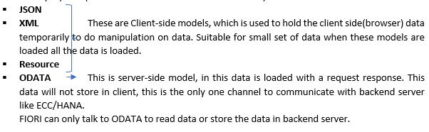

1. **Steps to create the model**
2. Define the model Object

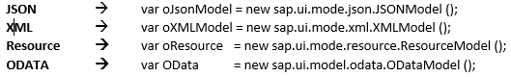

1. Load/Set the data into the model Object.

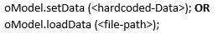

1. Set the model object to the application/view/UI control level.

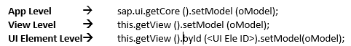

1. **Types of Bindings** - When we connect our view UI elements with model path, so that data can be exchanged between view and the model this concept is called data binding.

Types of bindings:

* **Property Binding 🡪**When we connect property of UI element with the path of our model then it’s called property binding.

We can apply property binding in multiple ways: Let’s take Input UI element.

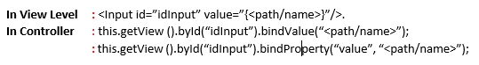

* **Element Binding 🡪**
* **Aggregation Binding 🡪** When we connect aggregation of the UI Element with the path of model is called Aggregation Binding.

**Ex:** For Table UI Element.

In Aggregation binding there are two paths - Absolute Path, Relative Path.

Absolute Path: A path which is provided in the UI element for aggregation binding is the absolute path.

Relative Path: A child element of the main UI element points to the path relative to the parent UI element path is relative path.

* **Expression Binding 🡪** we can bind the expression to a property of a UI Element, this expression is evaluated at runtime and supplies the value to the UI element.

SAPUI5 does not understand the expression binding syntax (Complex binding syntax), to make this binding understandable we should write below line under bootstrap.





1. **What are the various Types of Binding Modes available & its behaviour in SAP UI5/FIORI?**

There are three binding modes are available in SAPUI5.

* One way binding **-** Data flows from model to view, if model data changes, the corresponding bindings in the view data will update.
* Two way Binding **-** Data flows from model to view and view to model. If any changes in the view, the model will update.

1. **Fragments and dialogs** - Whenever we want to create a dialog in SAPUI5 we will be using **combination of fragments and dialogs**.

**What are the fragments and dialog:** Actually, to create a popup dialog we need only **dialog** UI element not fragment? We may have same input F4 help in some other views so we don’t want to write the same code in multiple places so to avoid this we will use fragments.

Fragments are light weighted views, which are used to keep reusable code. Which does not have the controller, the host view controller itself fragment controller. Host view ID itself fragment ID.

1. **What is Nested View? How to include one view inside another view?**

Nested views are used for reusable purpose, or to make the views are simple and not complex.

Below syntax is to call one view from the view.



1. **Why dialog is dependent of view.**

When we make our dialog is dependent of view, then only model (any model) will be applicable to that dialog.

Formatter is applied only in one direction i.e. mode to View.

1. **What is the purpose of Component.js**

Component.js is the like global controller any view controller can use this component.js.

In component.js file we load the meta data, initially we use to maintain the all-configuration related to metadata in component.js, in the year 2015 SAP has modularize this configuration code into configuration file called manifest.json.

In component.js file we need to initialize the router, the reusable methods also we can write in component.js file.

1. **Formatters** - This can be used to perform formatting the data before supplied to UI Element. This formatter is java script file.

**In View:**



**In Formatter.js**

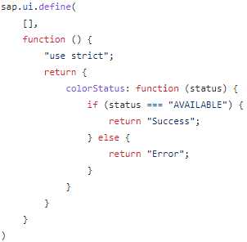

1. **Router Navigate to next View with parameters.**

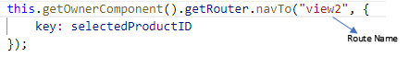

1. **Attach Pattern matched or how to collect the router parameter in next view.**

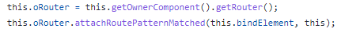

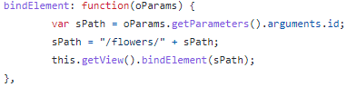

**OR**



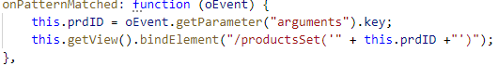

1. **Create Operation from Front-End Application.**

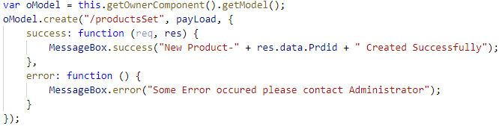

1. **FIORI tile creation (custom & Standard App).**
2. **Extending standard FIORI Application.**

Cross Application Navigation

Scenario based questions

**Capture selected values**

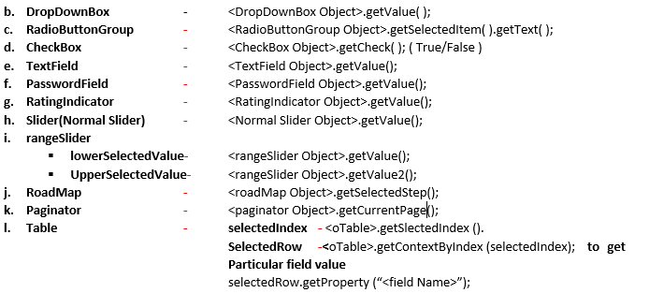

1. **Common Methods for most of the screen elements.**

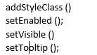

1. **To get/Set the Simple Form Fields.**

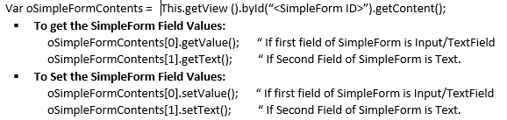

1. **To attach a function to event of Element.**

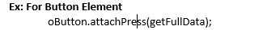

1. **Property Binding in Multiple Ways:**



* **Using bindProperty Method :** after Creation of Object for Screen Element, must apply bind property to that Object.





1. **Syntax to get the reference of view related screen elements inside respective view controller.**

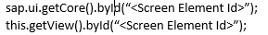

1. To get the Reference of the view in its controller by 🡪 **this.getView();**
2. **To get one column value of the selected row of a Table(sap.m.Table)**





**CSS- Cascading Style Sheet:**

**Step1: Create .CSS file and maintain CSS Properties.**

We can create .CSS file in webapp Folder / we can use third party, that we can maintain index.html file.

**Step2: Refer CSS File in our Program.**

1. Go to **Index.html** file and on Top implement as below line.

**Local CSS File:** <link rel=”stylesheet” type=”text/css” href=”mystyle.css”>

**Third party CSS:** <link rel="stylesheet" href="https://www.w3schools.com/w3css/4/w3.css">

**OR**

1. Go to manifest.json file and mention .CSS file as like below.

**Step3: Add CSS style class to SAPUI5 /FIORI screen elements.**

**In controller -** <Screen Element Object>.addStyleClass(“<style class Name>”);

**IN View -** <<Screen Element name> class= “<background>”>

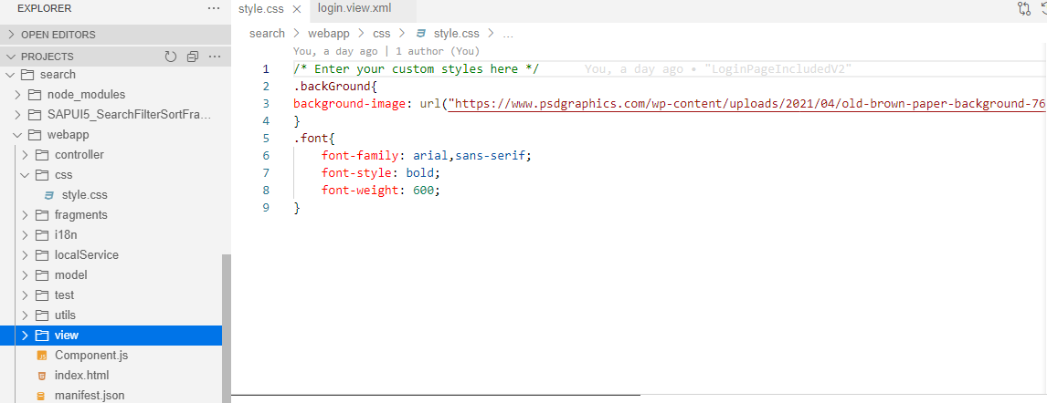

**ODATA**

1. **Create ODATA Model Object:**

Var oModel = new sap.ui.model.odata.ODataModel(

“<Service URL>” ,

True/false , (for XML/JSON)

UserID ,

Password);

1. **To get the ODATA Services from External.**

**URL:** [**https://www.odata**](https://www.odata)**.org/odata-services/**

External Services are developed by some other developers, and we are in position to develop the SAPUI5 Screen elements using given ODATA Service.

1. How to test either Data is coming to EntitySet or not?

Open REST Client in browser by installing it, using below link.

<https://chrome.google.com/webstore/detail/advanced-rest-client/hgmloofddffdnphfgcellkdfbfbjeloo>

In this app we must give external service name with EntitySet then we will get the Data.

1. **SAP Gateway client Request URI - /IWFND/GW_CLIENT**

* **To get the Metadata.**



* **To get multiple records using EntitySet.**



**Triggered Method -** productsSet_get_entitySet.

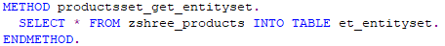

* **To get the Single record based on key field.** - **Select Single**



**Triggered Method in backend -** productsSet_get_entity.

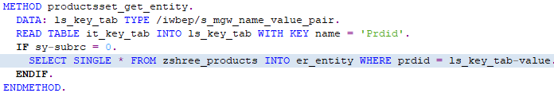

* **To apply Filters to EntitySet.** - **Where condition in select Statement.**





**Triggered Method in backend -** productsSet_get_entitySet.

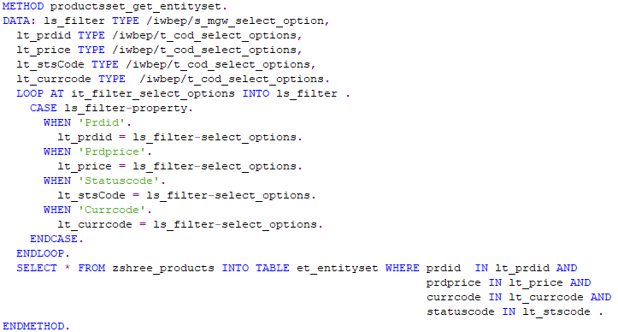

* **To apply Sorting to EntitySet.** - **Sort the internal table.**



**Triggered Method in backend -** productsSet_get_entitySet.

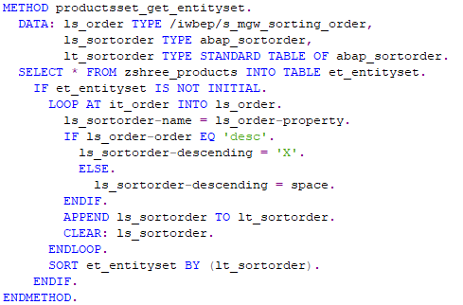

* **If we want to get the Items Related to Header Details.**



**Triggered Method in backend -** suppliersSet_get_entitySet.

For this we need to create the Association and Navigation.

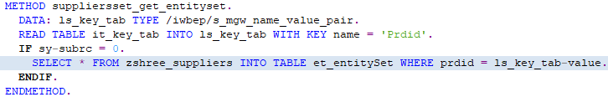

* **If we want to get the Header and its Item Details.**



**Triggered Method -** suppliersSet_get_entitySet.

* **If we want to create the header record.**

**Operation used in frontend** - create

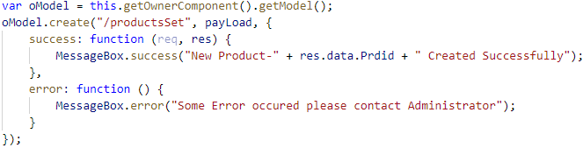

**Triggered Method backend - productsSet_create_entitySet.**

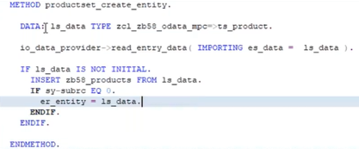

* **If we want to update the record.**

**Operation used in frontend** - update.

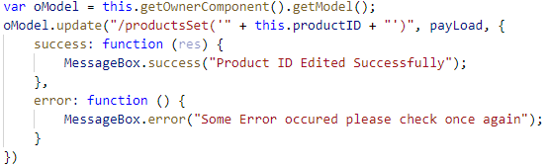

**Triggered Method backend -** productsSet_update_entitySet.

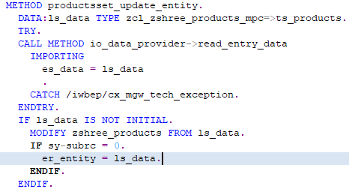



* **If we want to Delete the Header and Item records:**

**Operation used in frontend** - remove.

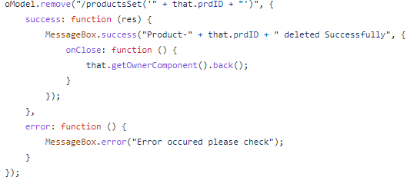

**Triggered Method backend -** productsSet_delete_entitySet.

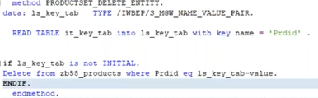

**YEOMAN Generator**

Each project has more-or-less same structure at the start time, So I need to be quick start of project using that structure. SAP WEBIDE does not provide me option to create a custom template which works for my team.

Using **YEOMAN Generator**, we can save our project template and we can use it while creating the same structure project from BAS.

**One way of getting template from Yeoman Generator:**

**Steps:**

1. We must find the template from **YEOMAN.IO** website and copy it.
2. From SAP BAS open terminal (ctrl+Shift+P) make sure you are on root directory(projects). Type **Open workspace** in terminal and press enter, then select **projects.**
3. Go to Command Prompt and type **npm install -g <template name>** the downloading this template to BAS. Then type **yo** and press enter and **select our template** and press enter. Then it will ask some necessary details like…

* **what project name would you like?**
* **Would you like to create a new directory for this project?**
* **what is the name space of your project?**

After all these commands we will get created project as per the yeoman Generator template.

**Another way of getting template from yeoman generator:**

**Steps:**

1. We have to install the Plugin/Extension in BAS. Go to Extensions, type **Yeoman** and you will get YEOMAN Generator on right side pane and click on install.
2. Open Terminal and type **Explore and install Generators,** here we can find the required template and install that template.

We can find this template while creating a new project using **open template wizard.**

1. Type Open template wizard in terminal(CTRL+SHIFT+P) and enter. Here we can select our installed template to create a new project(very similar to that template).
2. Then we will find new created project in right side pane.

Note: If we want to uninstall the template from SAP BAS, open **terminal** and type **Explore and Install Generators** and select the template which is already installed and press on **Uninstall**.

**Deploying SAPUI5 application to SAP Server/SAP on-Premises System from SAP BAS:**

Before we deploy the app to ABAP system from SAP BAS, let’s do a quick check on pre-requisites:

1. For deploying to SAP S/4HANA on premise, you need to set up an on-premises destination and the cloud connector. See Cloud Connector.
2. Make sure to add the **HTML5.Timeout**= 60000 additional property to your destination.
3. Make sure that your **WebIDEUsage** includes **dev_abap** for deploying to the SAPUI5 ABAP Repository. (For example, your WebIDEUsage includes odata_abap, dev_abap).
4. For deploying to SAP S/4HANA on premise, you should add the sap-client additional property to your destination.

Once all the pre-requisites are in place and the application is tested successfully, we are good to go for deployment of application to SAP on premise system which we configured on cloud connector.

We should follow below steps:

1. Right click on your Project and select Open in Terminal.
2. Run the command in terminal **npm install -** Once npm is install it will create npm folder under project directory.

If you see any vulnerabilities, you can run **npm audit** command.

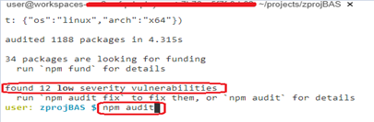

1. Run the command **npm build / npm run-script build.**

Once the project is build it will look like below.

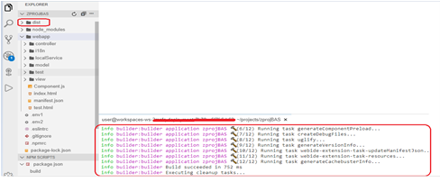

1. Run the command **abap-deploy**. Then it will ask the below specifications.

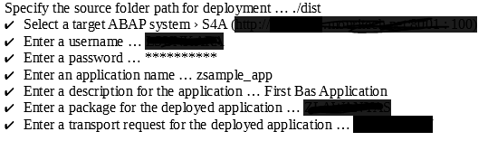

Now it will ask to provide package and Transport Request number:

You can deploy app using $TMP also in case you do not have package and TR.

**Note:** TR should be workbench request.

Once you deploy to ABAP server you can find it under **BSP applications**. Now you can configure your UI5 application on Fiori launchpad and assign the roles to use them.

Now let’s test the application from SAP ABAP System where we just deployed the app.

Login to SAP system to test the app.

Open Tcode **SICF** and search for the project name which we use while deployment <ProjectName>in service name and execute (F8): or default_host🡪 sap🡪bc🡪bsp🡪sap🡪project_name **or** default_host🡪 sap🡪bc🡪ui5_ui5🡪sap🡪project_name.

Right click on service and click Test:

It will open the application on browser and will ask for your SAP credentials:

**At point 4 -** if you wish to deploy with logs: **abap-deploy –log-level=error**), log level could be (off, fatal, error, warn, info, debug, trace) and will be written to the abap-deploy.log file which will get created under project.

Once the app is deployed with setting log level as error, abap-deploy.log file will get created in project automatically:

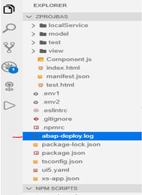

**Reference Link-**

<https://blogs.sap.com/2020/10/29/develop-deploy-sapui5-fiori-like-app-using-sap-business-application-studio-bas-and-troubleshooting/>

**Points to keep in CV**

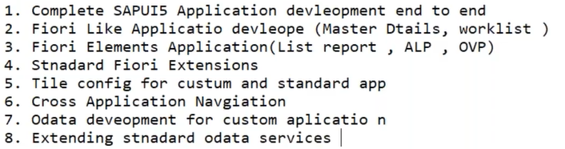

**Reference Useful Link:**

* [**Fiori elements**](https://wiki.scn.sap.com/wiki/display/Fiori/Fiori+elements)

<https://wiki.scn.sap.com/wiki/display/Fiori/Fiori+elements>